[Week 3](https://www.coursera.org/learn/introduction-to-data-engineering/home/week/3)

Architecting the Data Platform

Data Ingestion or Collection Layer

Tools for data ingestion

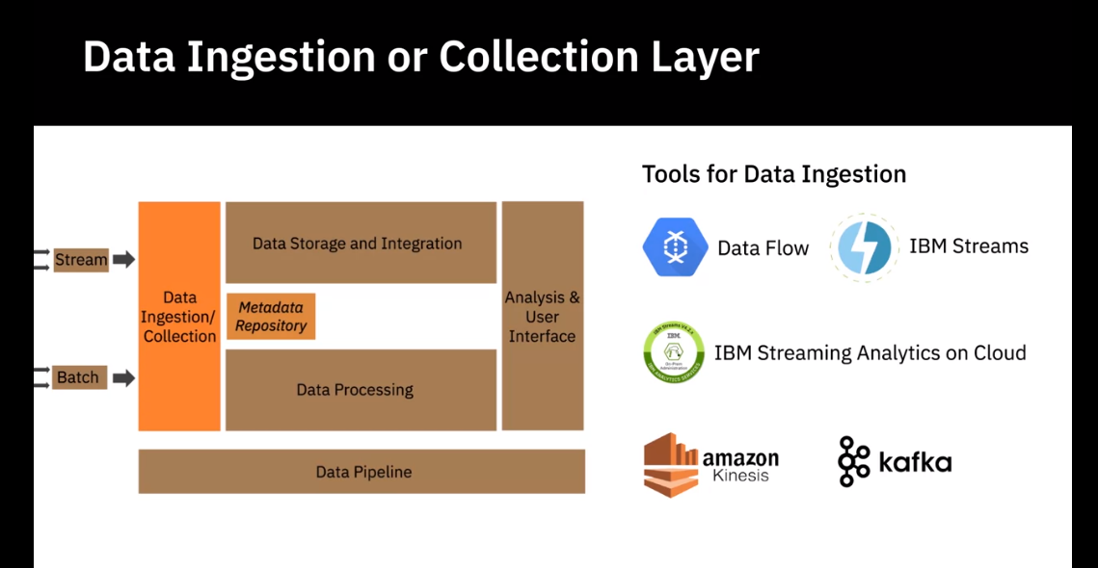

Data Storage Layer

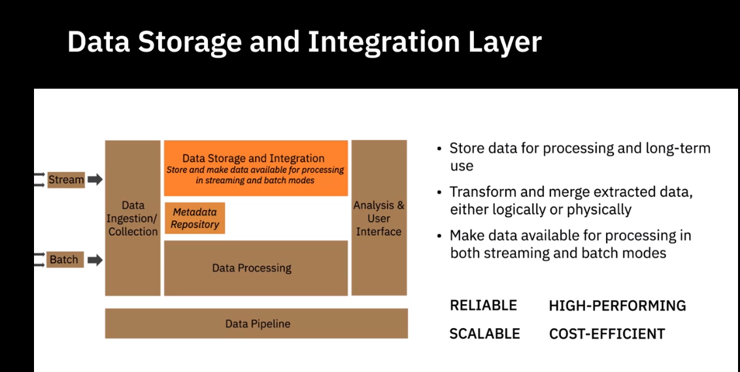

Ralational Databases

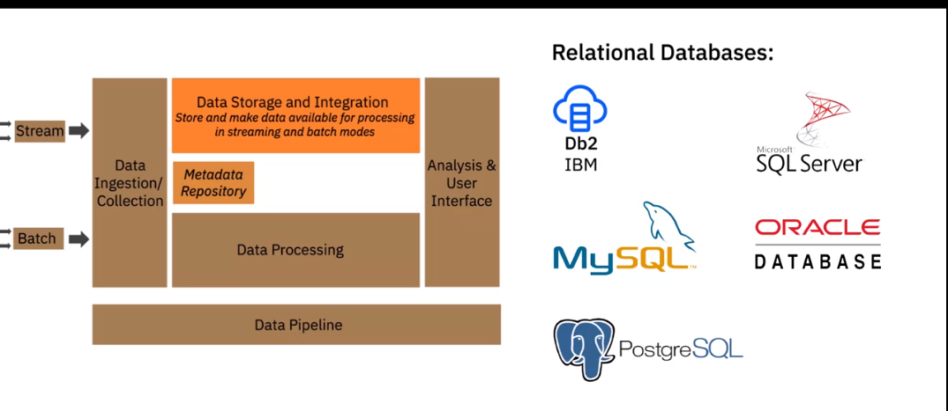

Database as a service

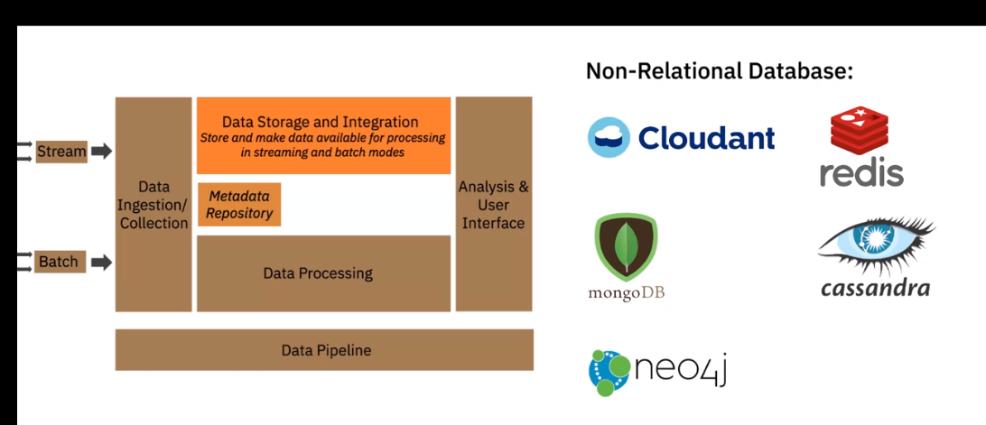

Integration Tools

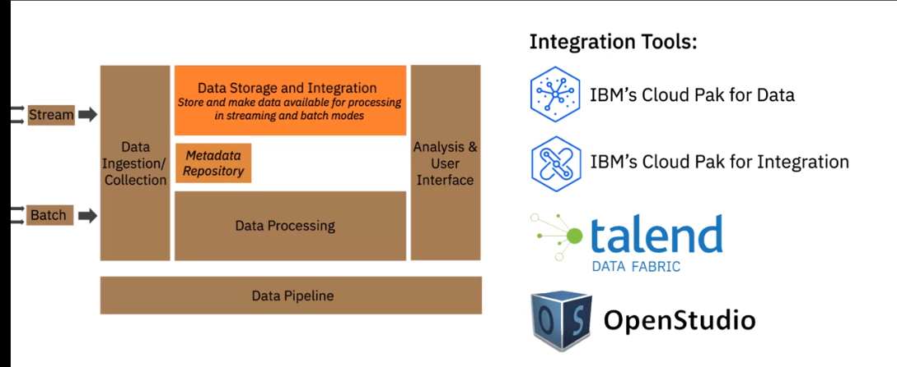

Data Processing Layer

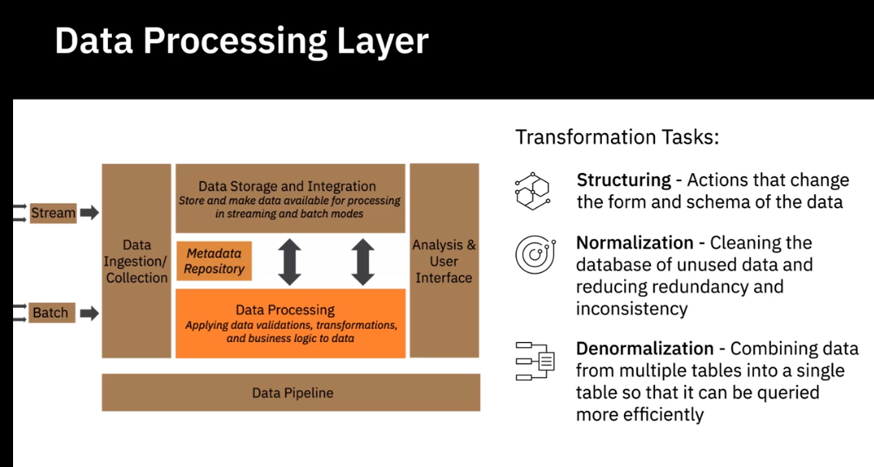

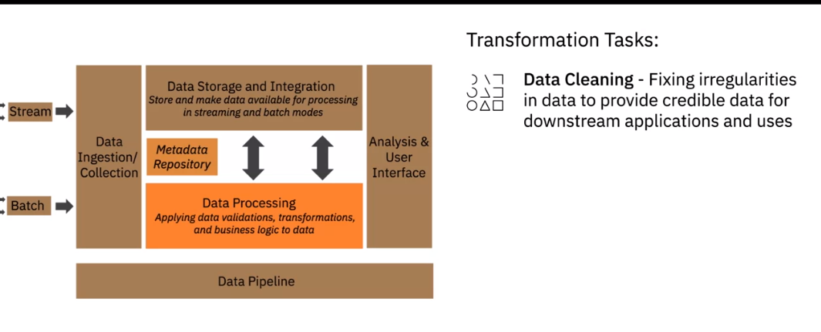

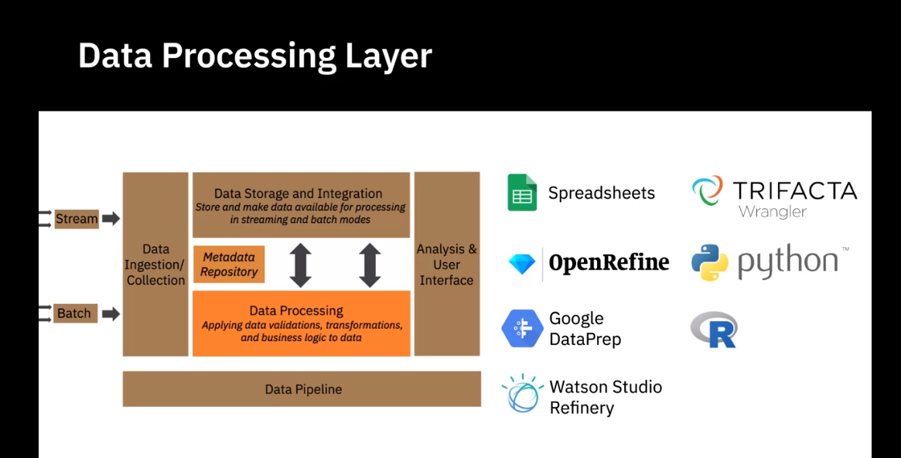

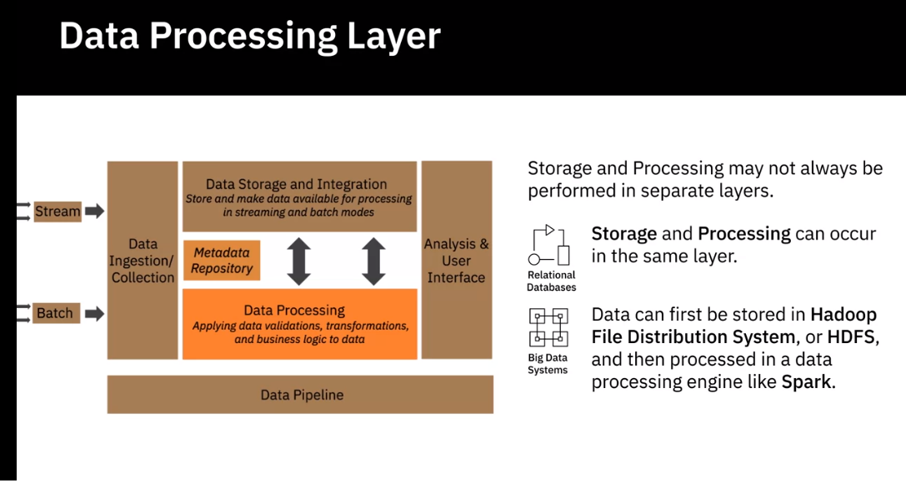

Analysis User Interface Layer

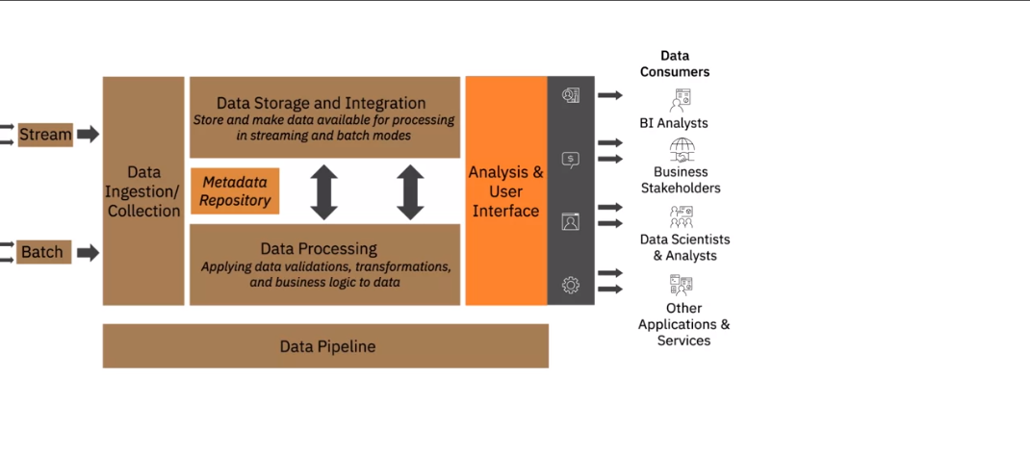

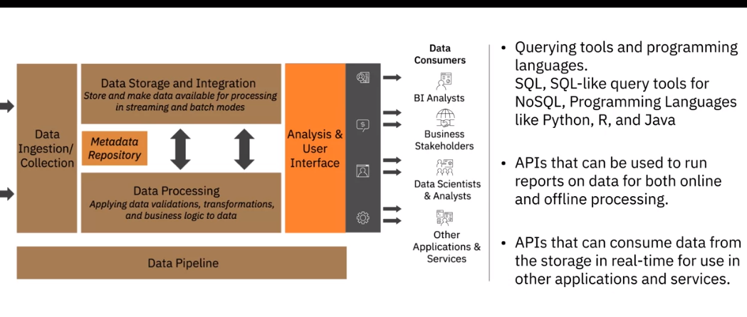

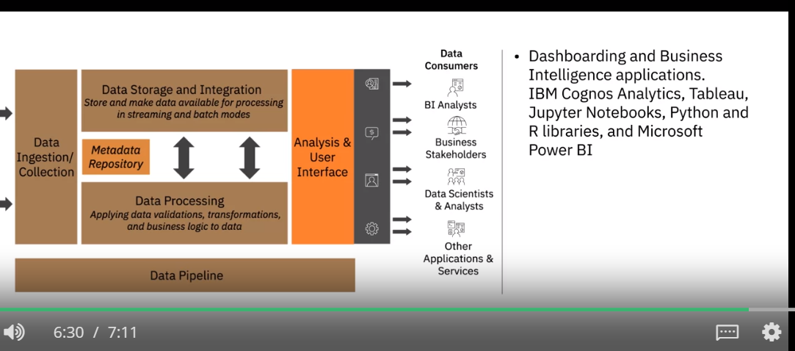

Data Pipeline Layer

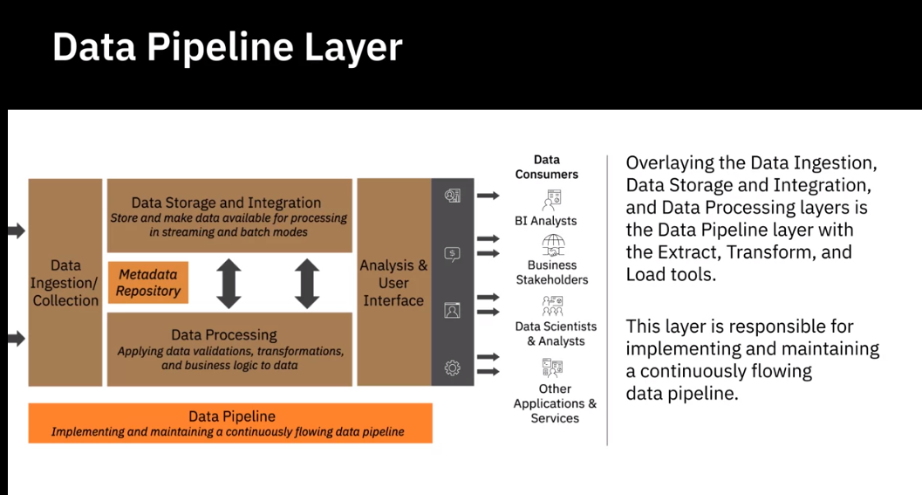

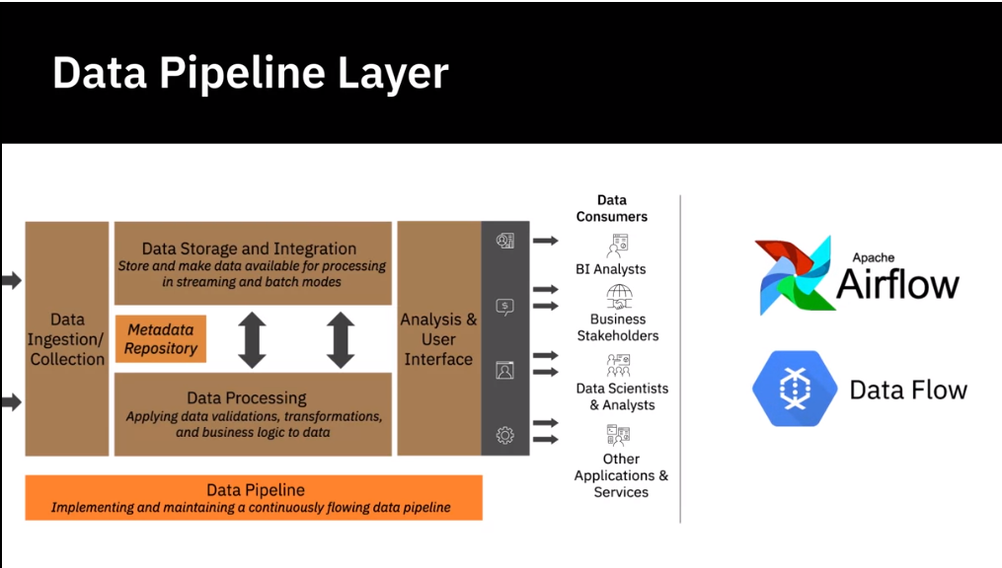

**Factors for Selecting and Designing Data Stores**

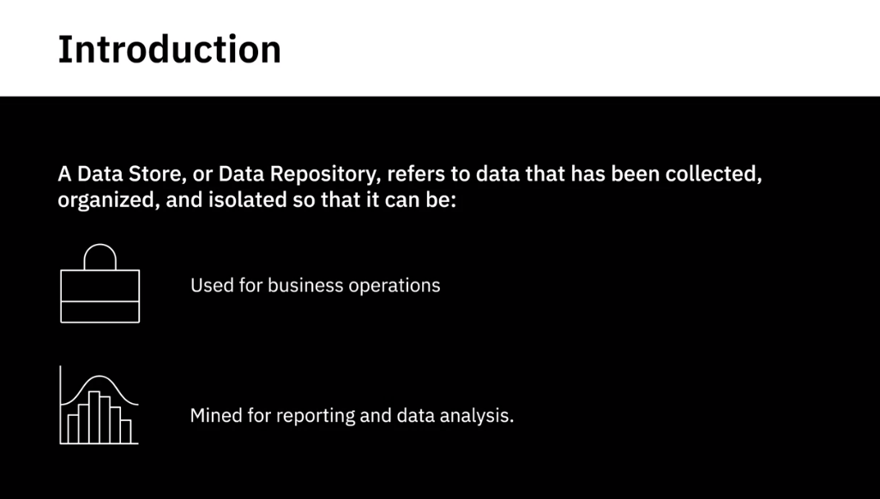

Considerations of designing a data store

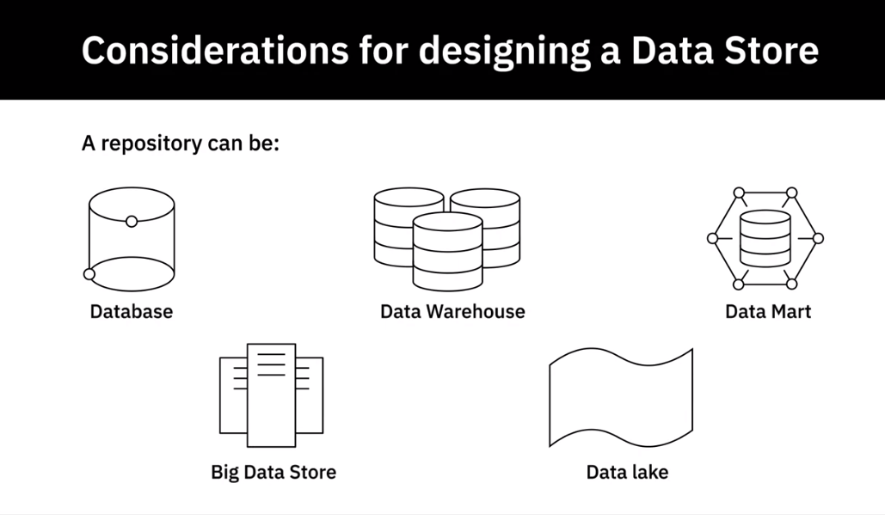

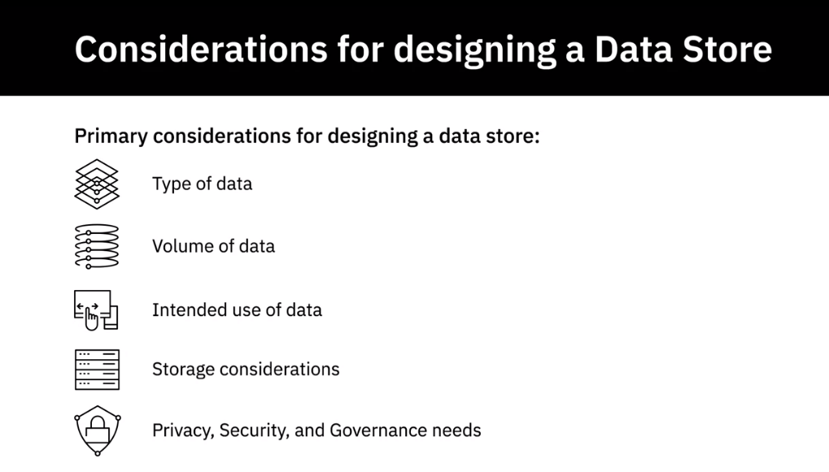

Type of Data

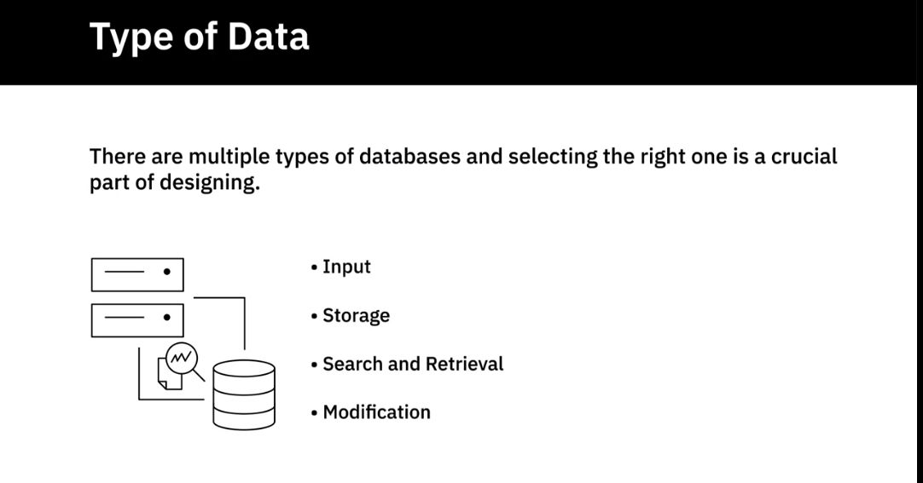

Type of Database

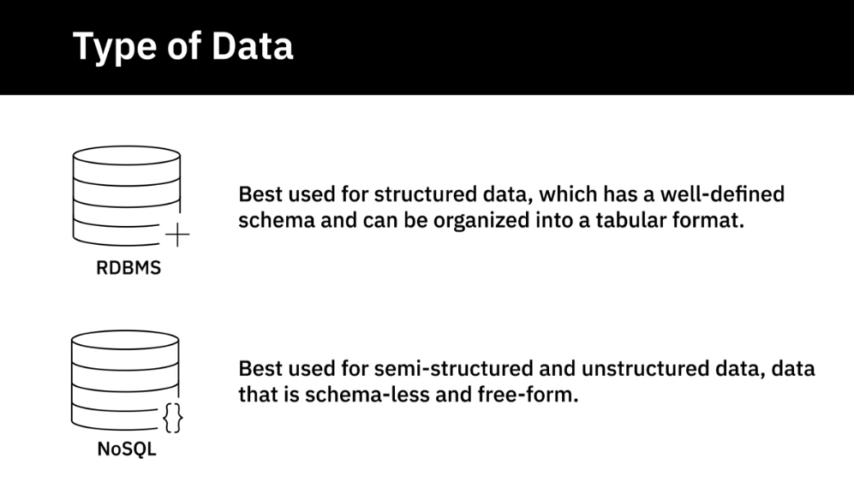

Type of nosql database

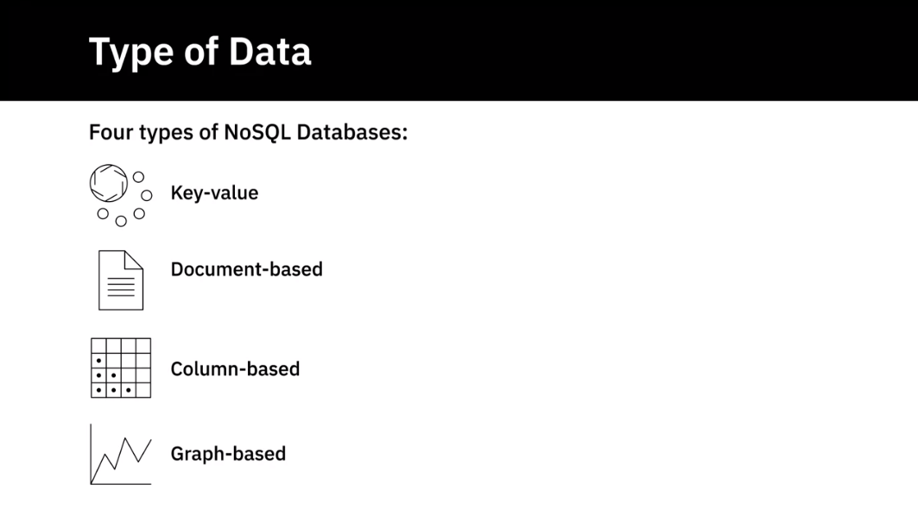

Volume of Data

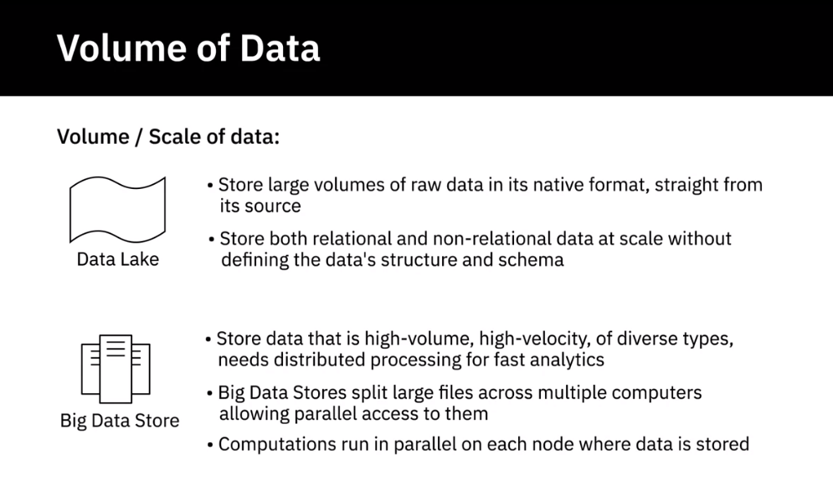

Intended use of Data

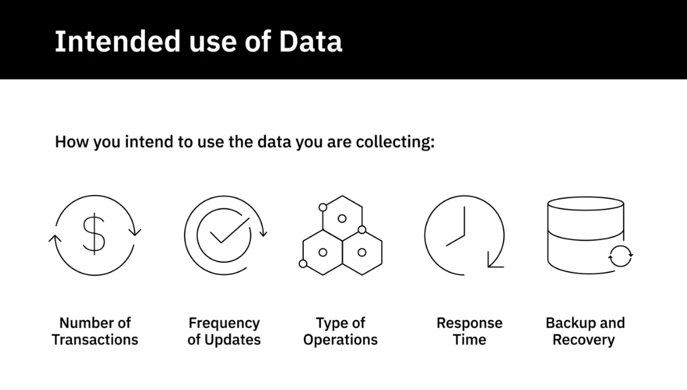

Intended use of Data

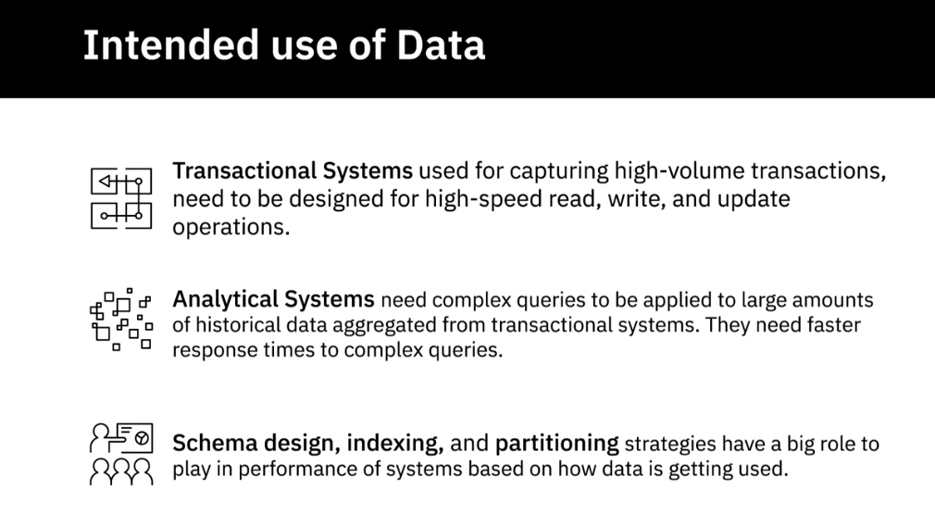

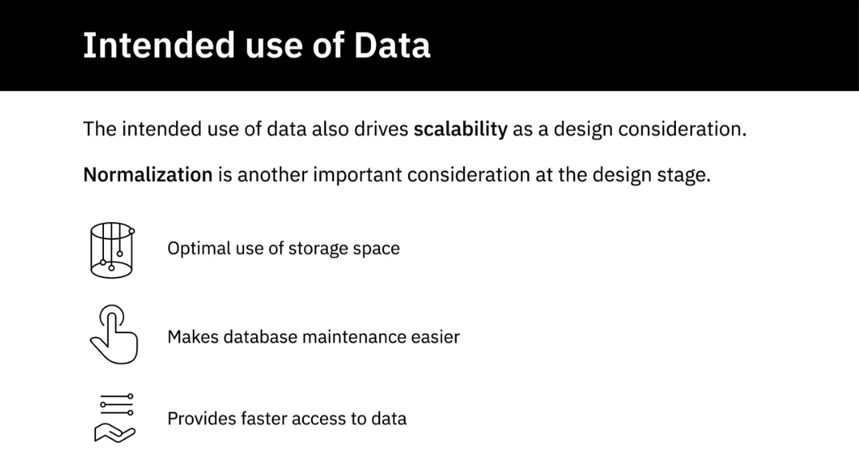

Normalisation: Transactional Data

Storage Considerations

Performance, availability Integrity and recoverability

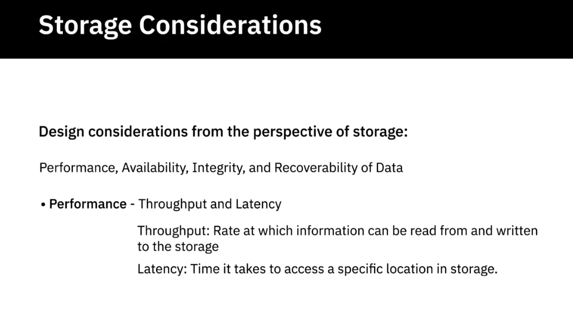

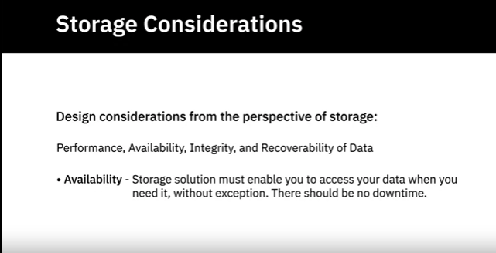

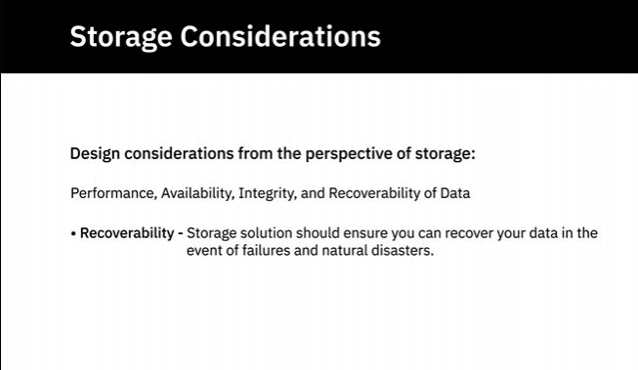

Privacy Security and Governance

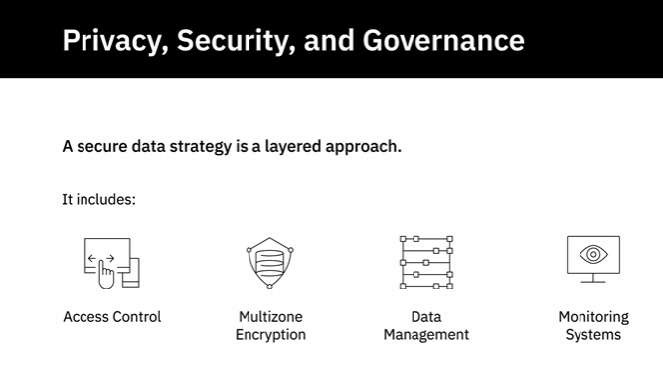

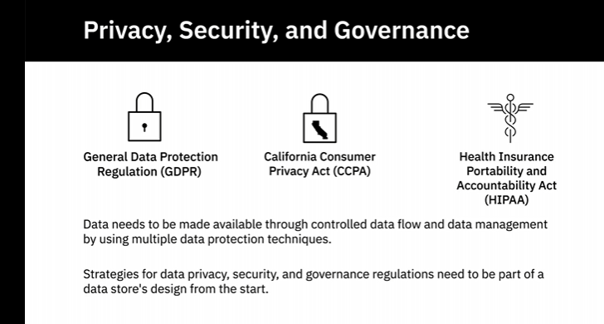

**Security**

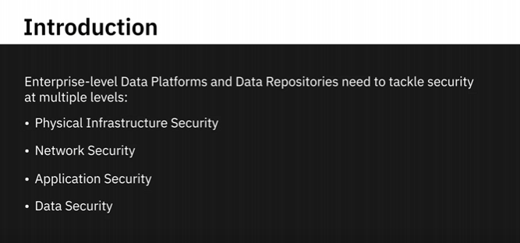

The CIA Triad

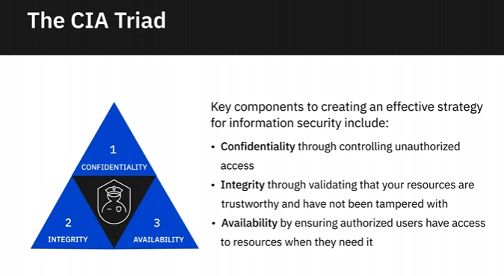

Application

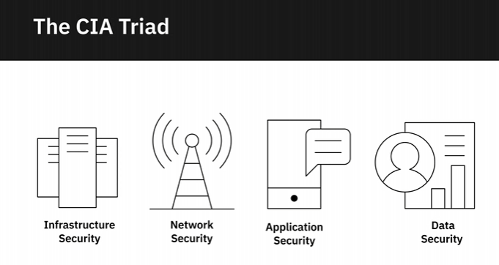

Physical Infrastructure Security

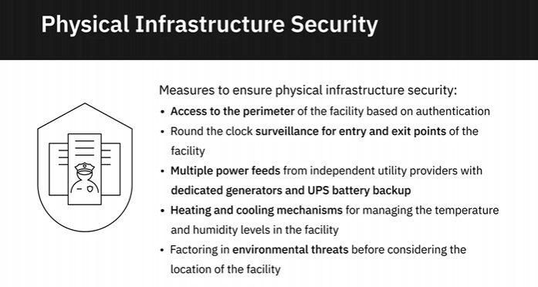

Network Security

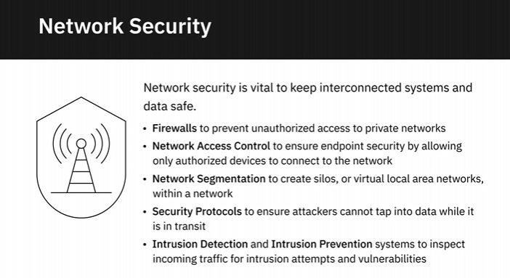

Application Security

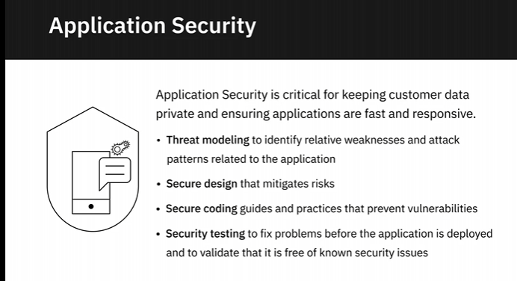

Data Security

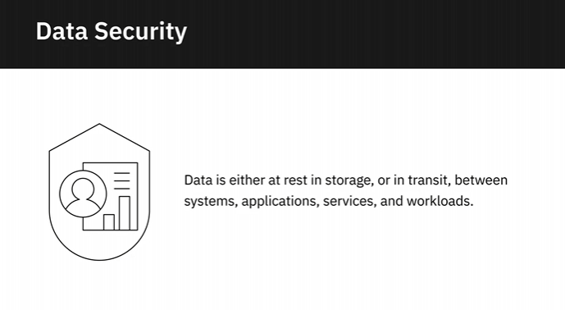

Authentication

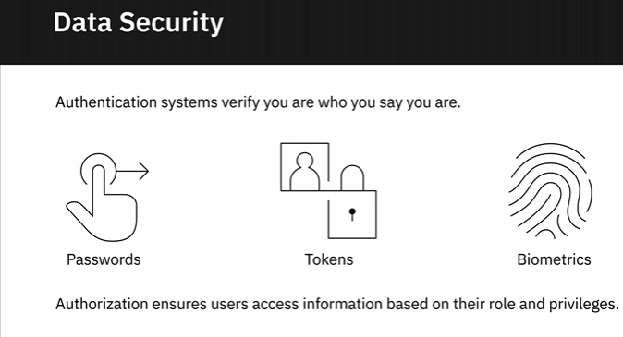

Data at Rest and Data in Transit

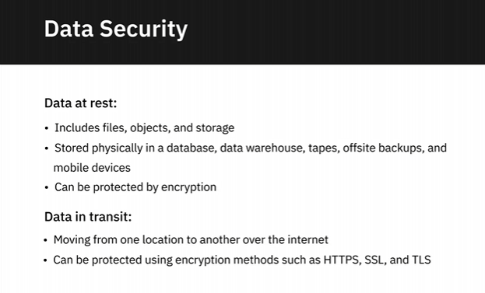

Monitoring and Intelligence

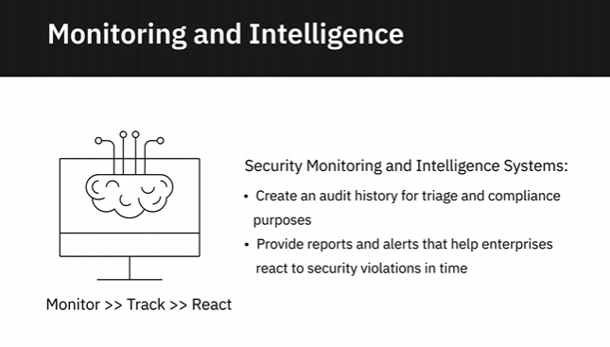

**Viewpoints: Importance of Data Security**

In this video, we will listen

to several data professionals talk about the importance of

data security as it relates to data engineering. So if your data is not secure,

nothing else about it really is going to matter in the long run.

There are many companies who are examples of serious data

breaches, and while that won't necessarily put you out of

business these days, that depends on the size of your

organization somewhat to begin with. If you're a smaller

organization and you lose access to your own data, that's

certainly a potentially company-ending problem. You really

can't understate the importance of data security. It's often

something we think of, oh we'll, harden it after go live or we'll

harden it just before go live. But really it's something that

you have to be thinking about data security along every step

of the way. The importance of security of data can't be stressed enough. A few years

ago, The Economist magazine published an article saying the

world's most valuable resource is no longer oil, but data. So if data is the most valuable

resource an organization has, it needs to be secured and protected. And failure to do so

can have catastrophic consequences. So data security, governance, compliance, these

are not just things that a data engineer needs to worry about. This needs to be an important

part of not just the data architecture, but the entire

organizational processes and every part of the organization

needs to keep on top of these things. We have to make sure

that when we have separate production and non-production

environments that our production data doesn't get unmasked into a

lower environment. There are absolutely data breaches that

can happen that way. We have to think about making sure that

people who have access to production data really need that

access to production data. The important thing is to understand

the security levels and roles for the tool you're using, and

make sure that each user is getting the least privilege

they need in order to do their jobs. It's when we give people

more access that we really open things up to data breaches

and data security problems. Most of the threats to your data

are actually more likely to come from within your organization

than without. It may be exciting, or whatever, to think of

somebody coming from outside of your organization to get to your

data, but most often that threat is going to come from inside your organization. A lot

of the things that we hear about in the data profession are

things like people at prescription drug places

accessing the prescriptions of celebrities. There are things

along those lines that we have to be very careful in

protecting the data. Data is a natural resource these

days, right? The world of Big Data, data is oil, that's our new

natural resource. So it's our job to make sure that that financial aspect of

valuable data is protected and that our organization is

not at risk for being in the news as one of those causing

a data breach or even worse, being put out of business

because of a data breach. I consider part of data

security, the ability to restore my data and the ability to

recover if a particular set of hardware fails. To me, that's

part of security, because if we lose the data because of a

hardware failure, that means we don't have access to the data,

which is part of data security in my own estimation.

## Data Collection and Data Wrangling

**How to Gather and Import Data**

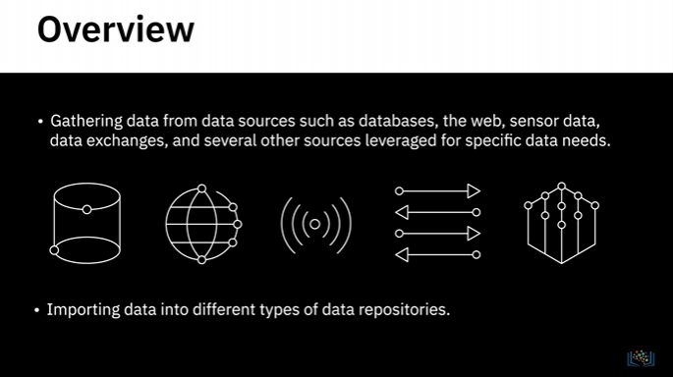

**Using queries to extract data from SQL databases**

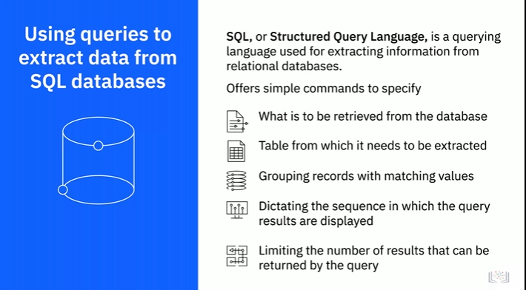

Nosql

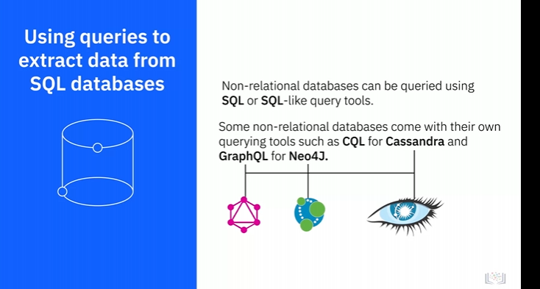

APIs

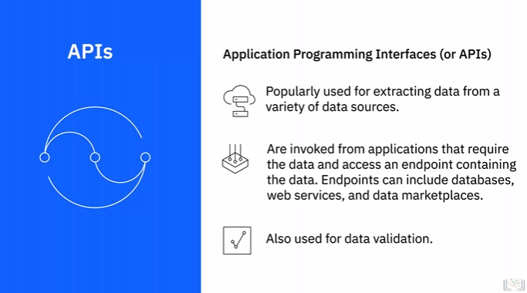

Extracting data from the Web

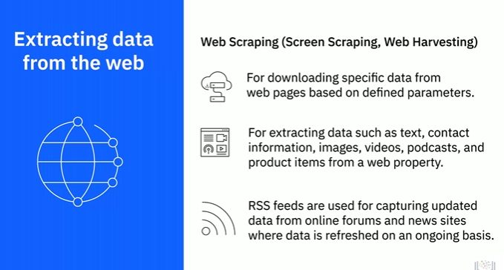

Sensor Data

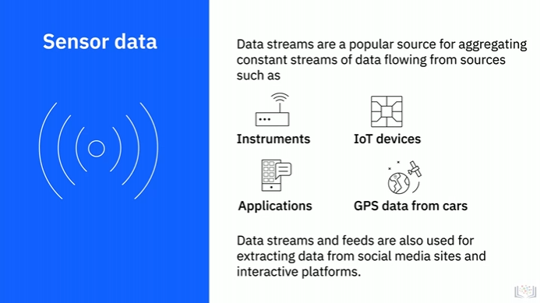

Data Exchanges

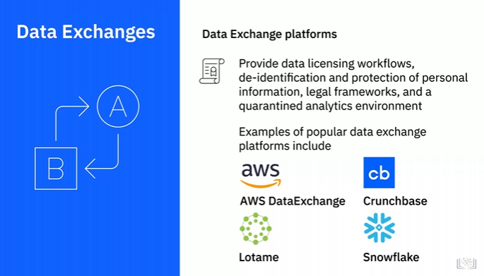

Other Sources

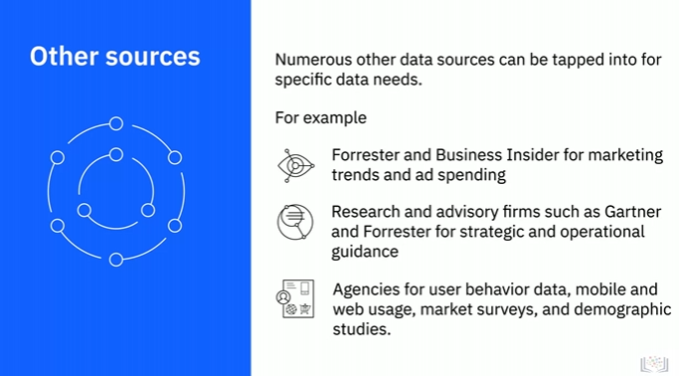

Importing Data

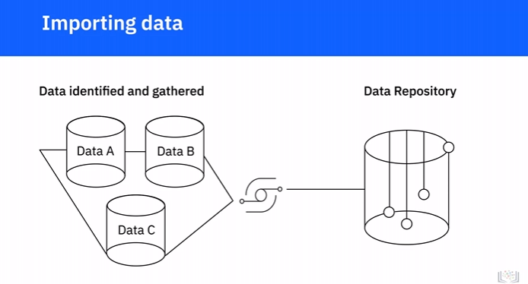

Combined view or single interface

Data type and destination repositories

Dstructured

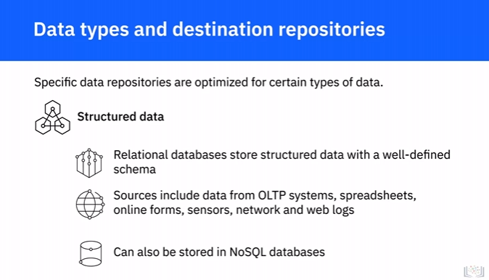

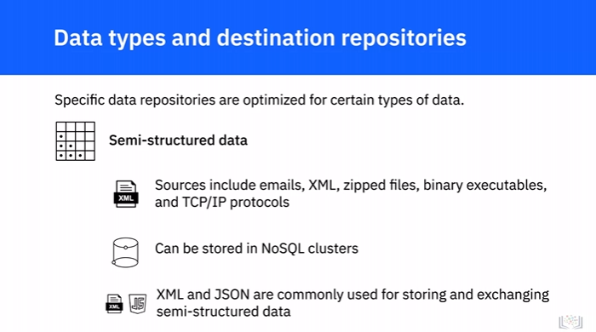

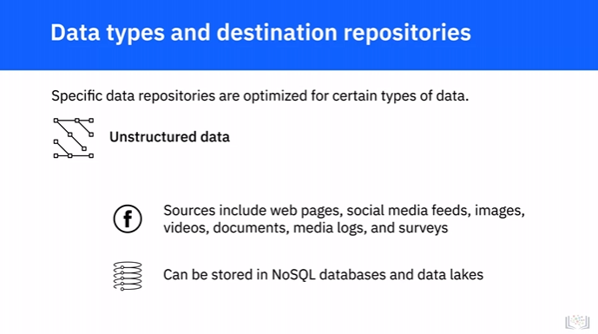

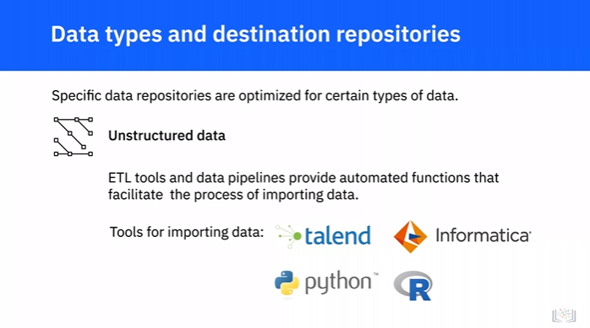

**Data Wrangling**

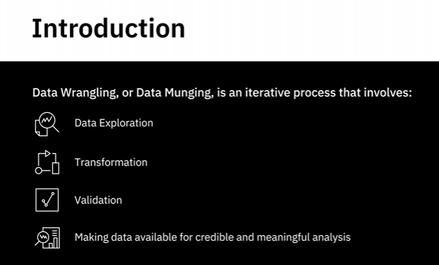

Transformation

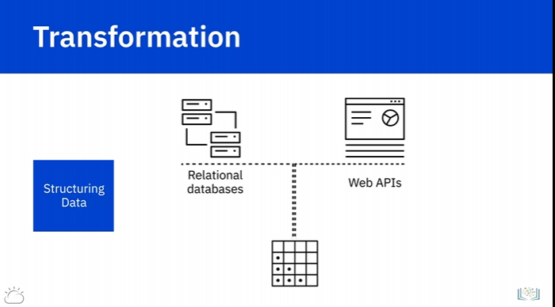

Joins and Unions

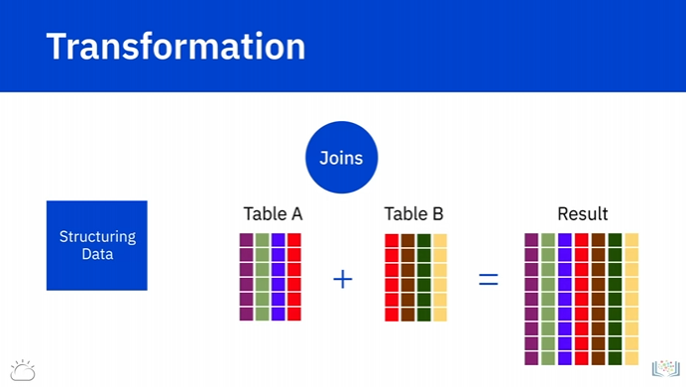

When two tables are joined together, columns from the first source table are combined with

columns from the second source table—in the same row.

So, each row in the resultant table contains columns from both tables.

Unions

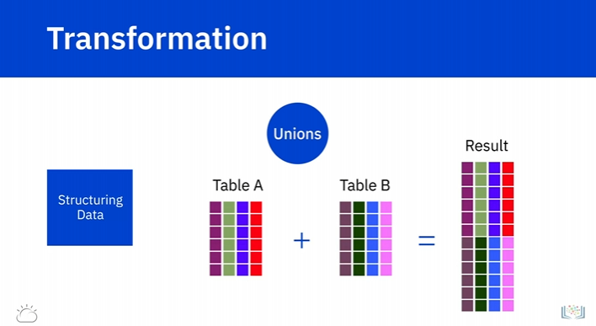

Unions combine rows.

Rows of data from the first source table are combined with rows of data from the second

source table into a single table.

Each row in the resultant table is from one source table or another.

Normalisation and Denormalization

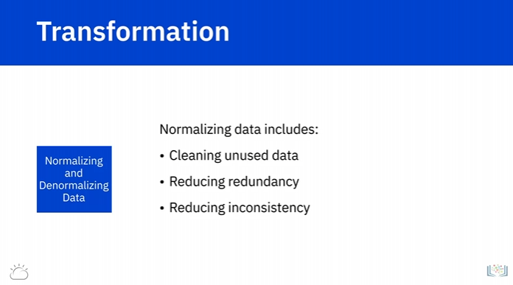

Transformation can also include normalization and denormalization of data.

Normalization focuses on cleaning the database of unused data and reducing redundancy and

inconsistency.

Data coming from transactional systems, for example, where a number of insert, update,

and delete operations are performed on an ongoing basis, are highly normalized.

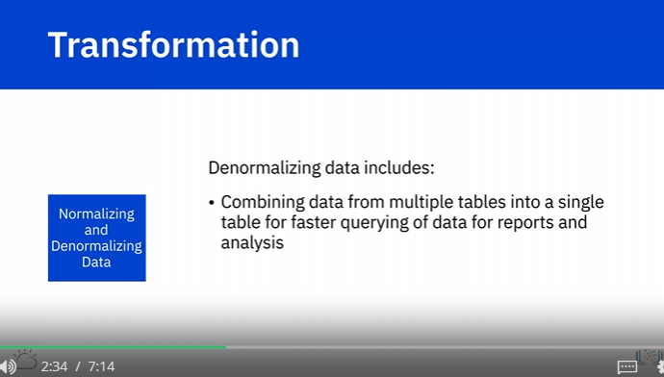

Denormalization is used to combine data from multiple tables into a single table so that

it can be queried faster.

For example, normalized data coming from transactional systems is typically denormalized before running

queries for reporting and analysis.

Cleaning

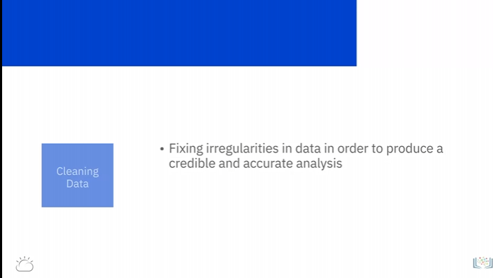

Data cleaning workflow step 1: Inspection

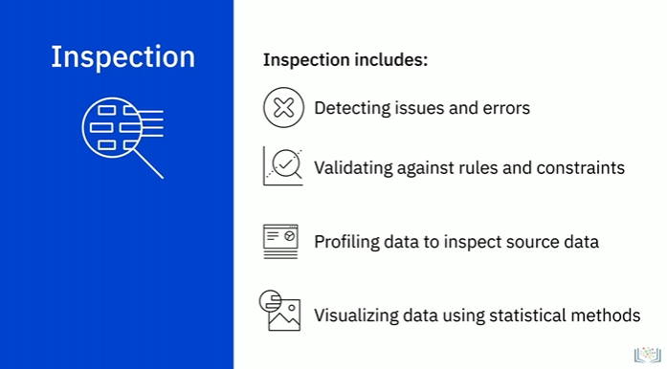

Data profiling

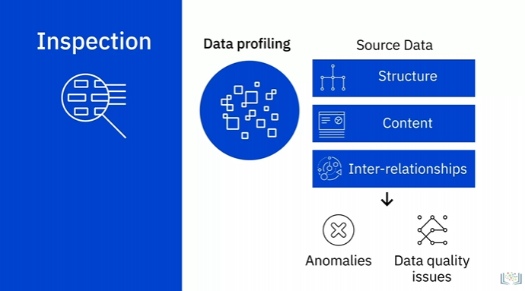

Visualizing the data

Cleaning of Data

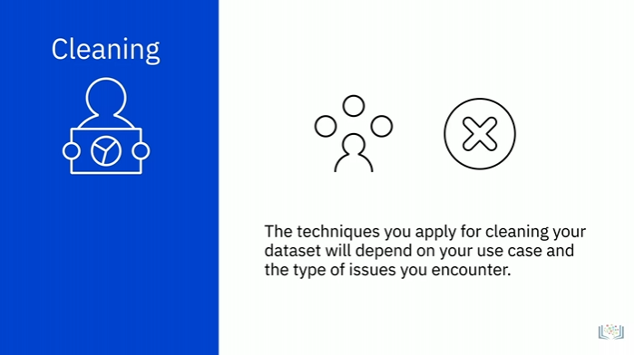

Common Issues

Dealing with Missing Values

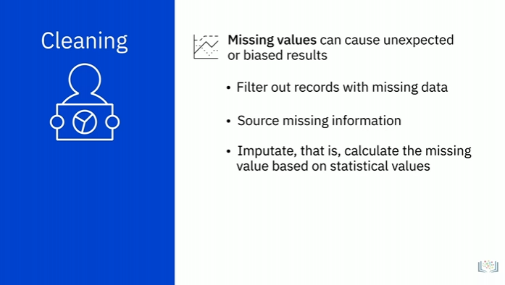

Duplicate Data

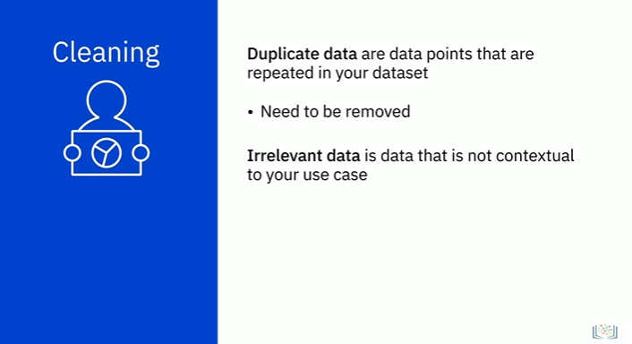

Data Type Conversion

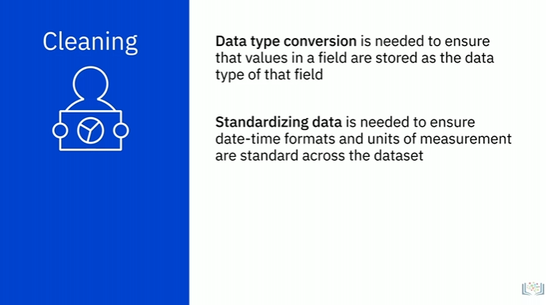

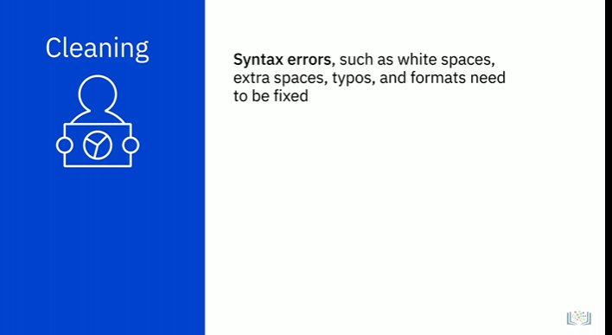

Outliner

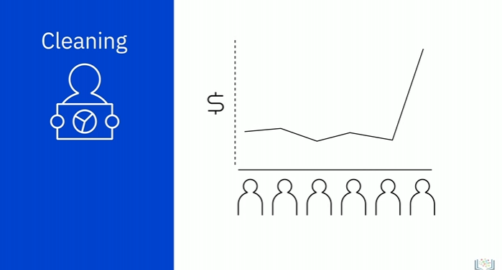

**Tools for Data Wrangling**

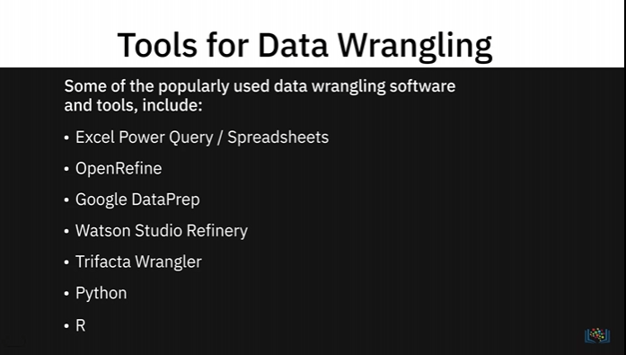

Excel Power Query/ Spreadsheet

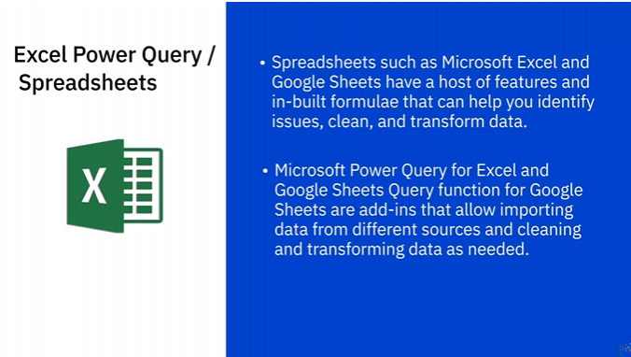

OpenRefine

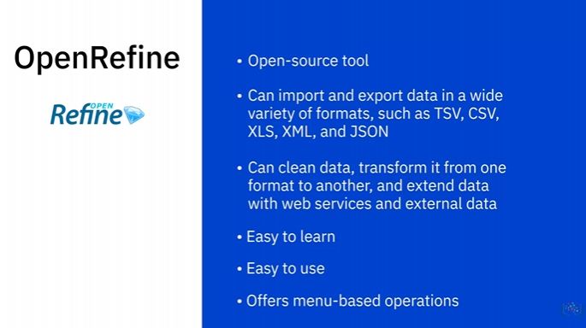

Google DataPrep

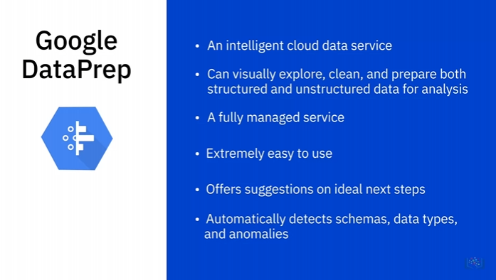

Watson Studio Refinery

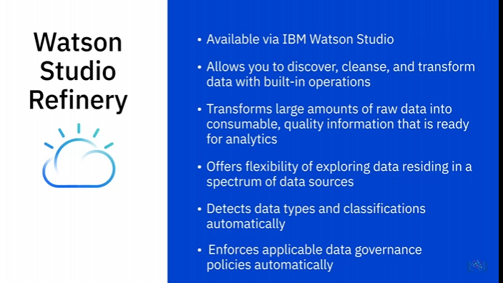

Trifacta Wrangler

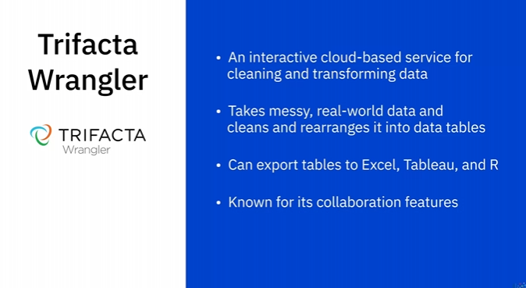

Python

Jupyter Notebook

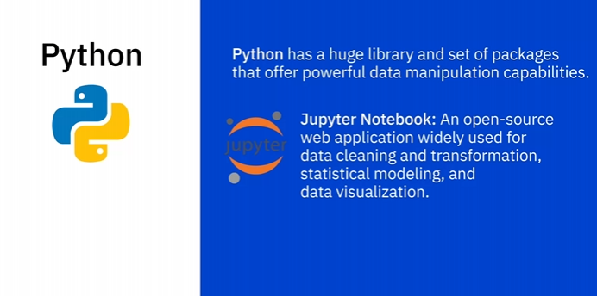

Numpy

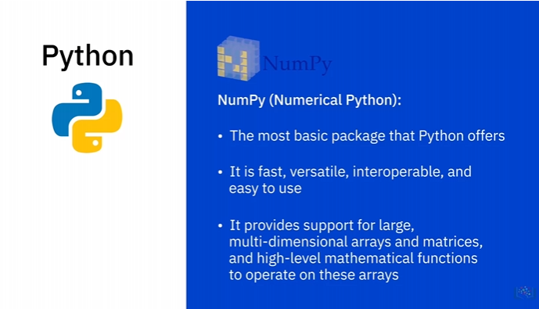

Pandas

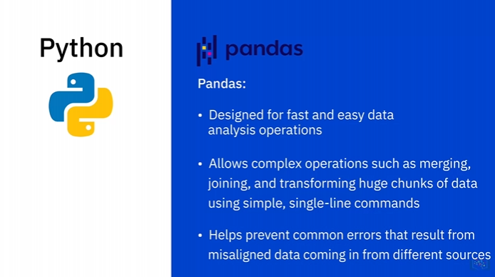

R

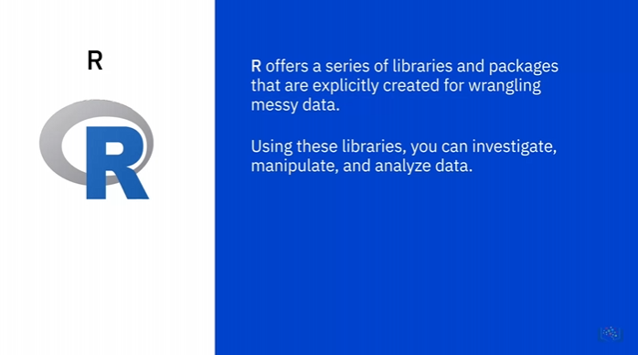

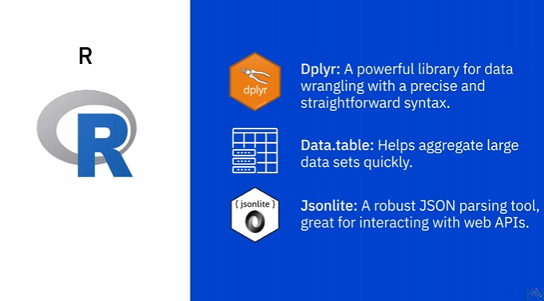

Tools for Data Wrangling

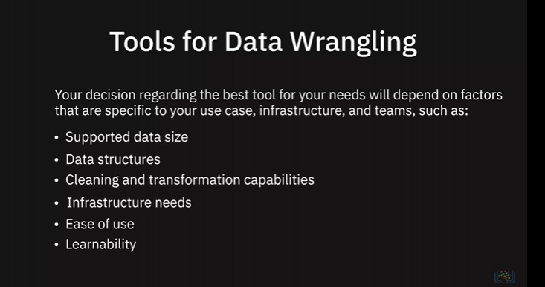

## Querying Data, performing tunning and troubleshooting

**Querying and Analyzing Data**

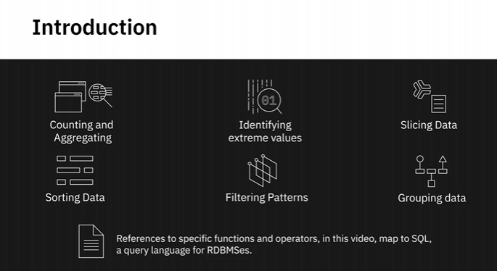

Counting

Example

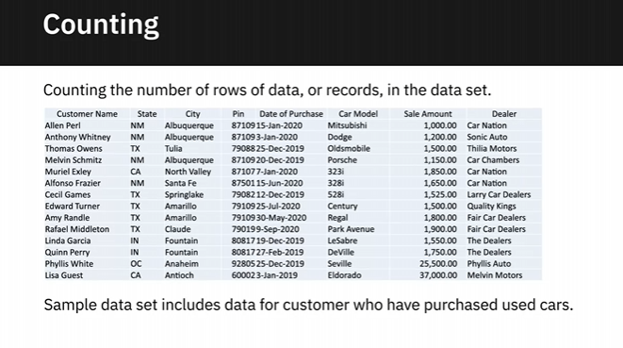

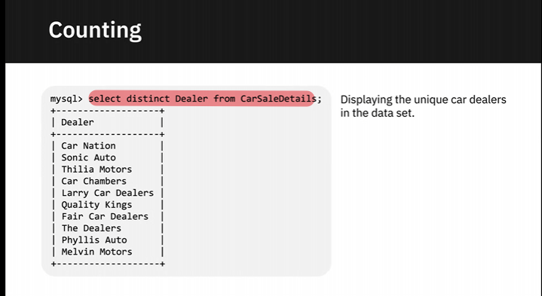

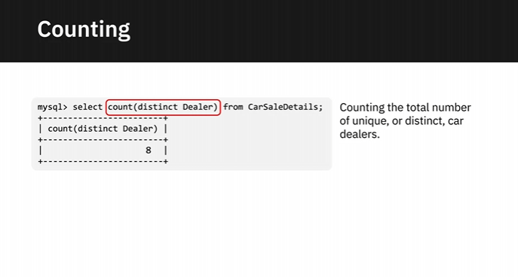

SELECT COUNT(DISTINCT Dealer) from CarSaleDetails;

Aggregation

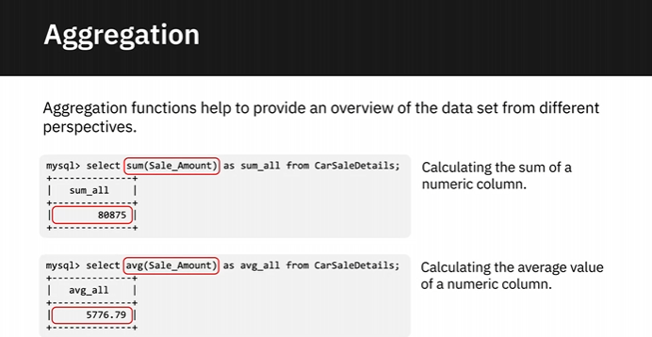

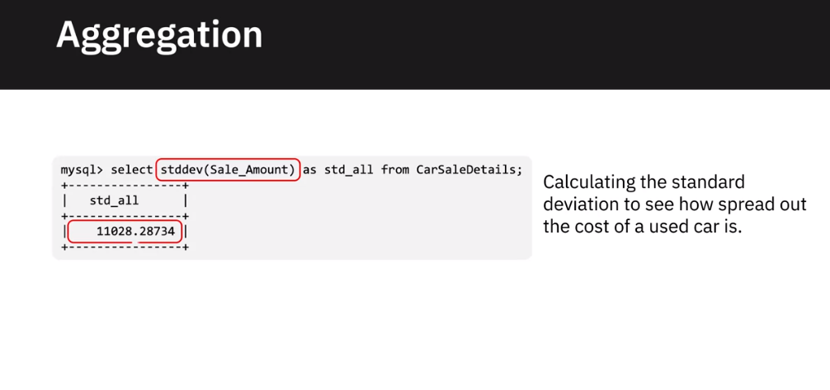

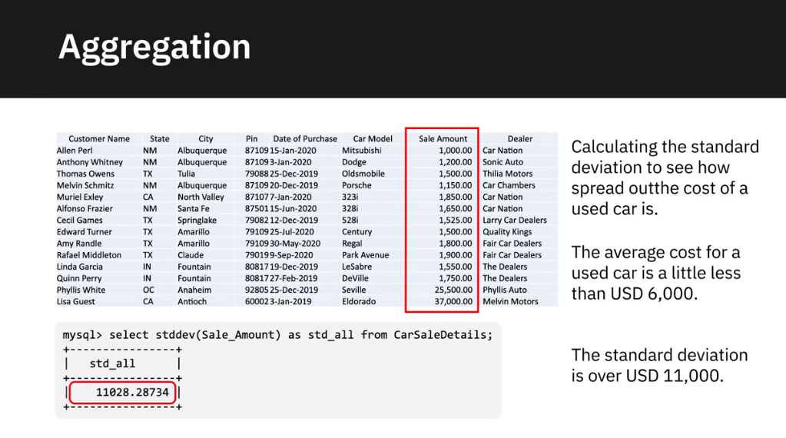

Extreme Value Identification

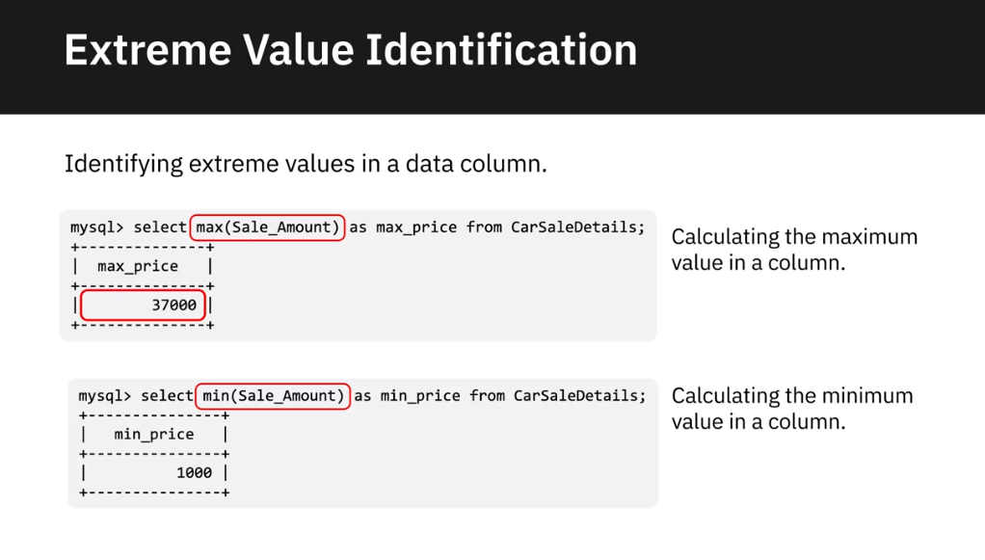

Slicing Data

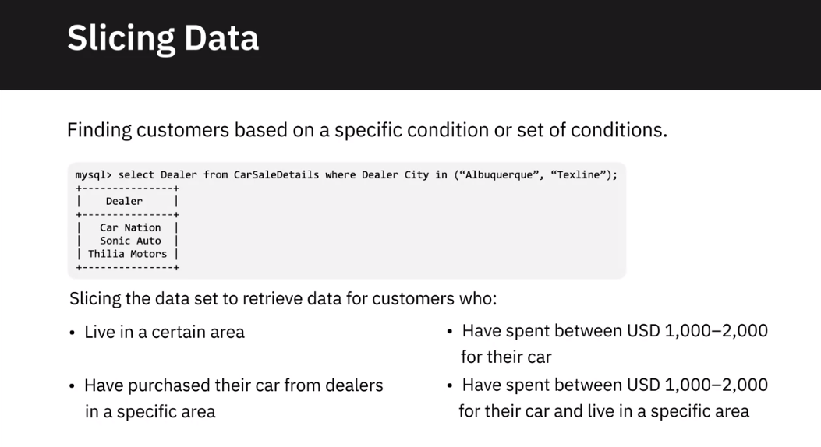

Sorting Data

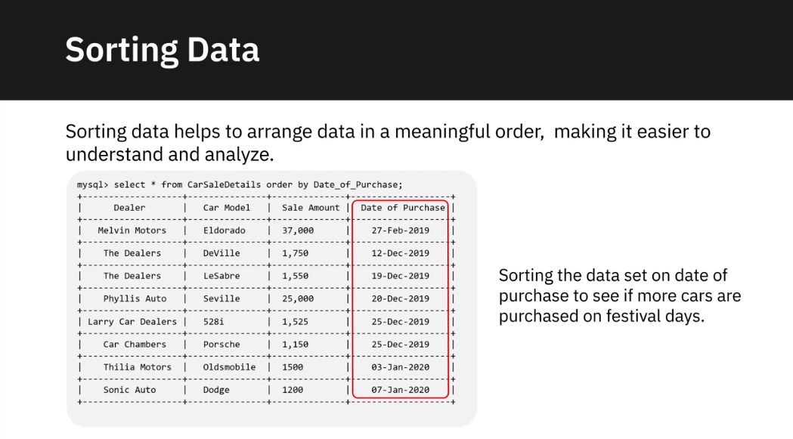

Filtering Patterns

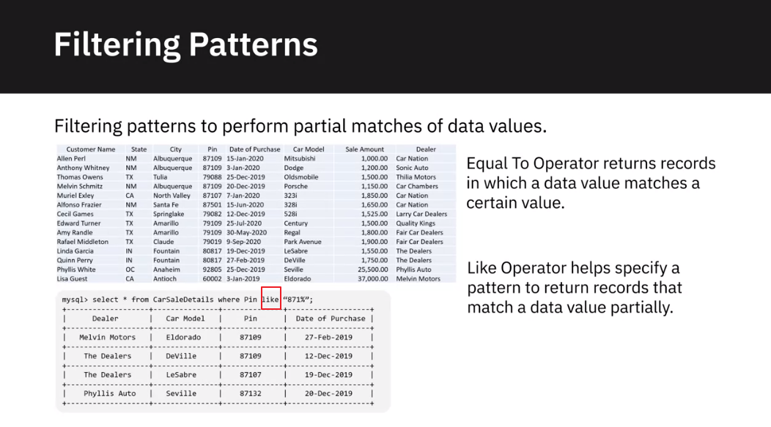

Select * from CarSaleDetails where

Grouping Data

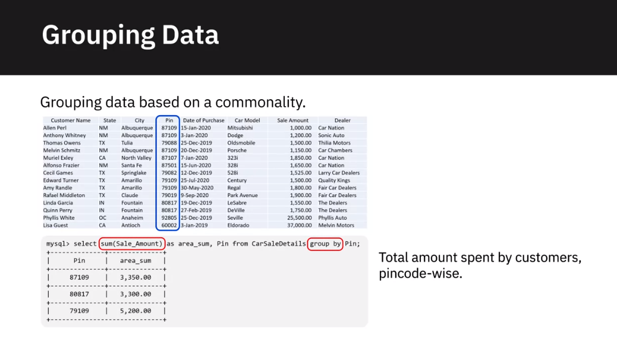

**Performance Tuning and Troubleshooting**

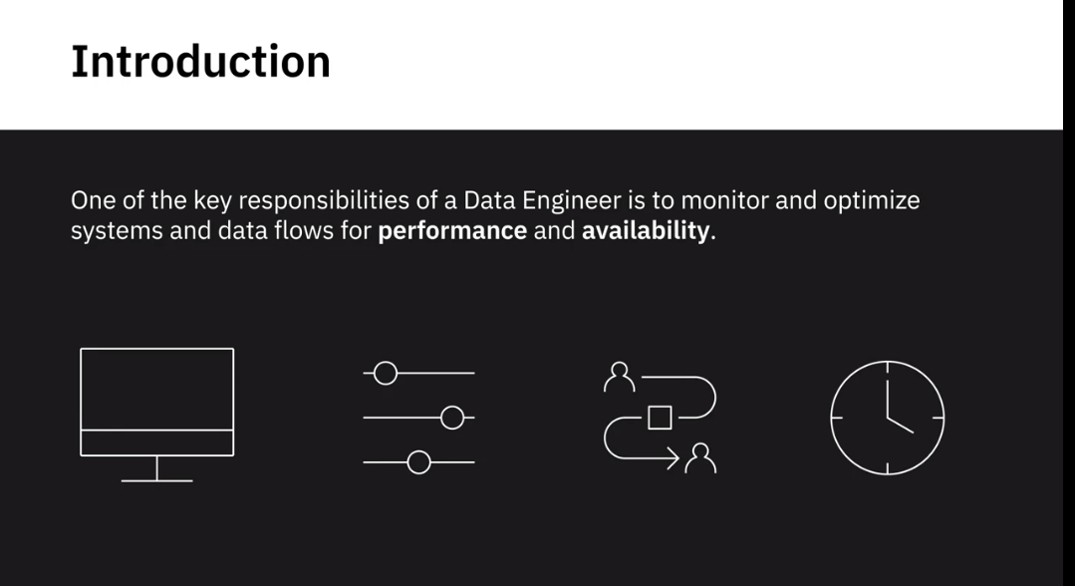

Data Pipelines

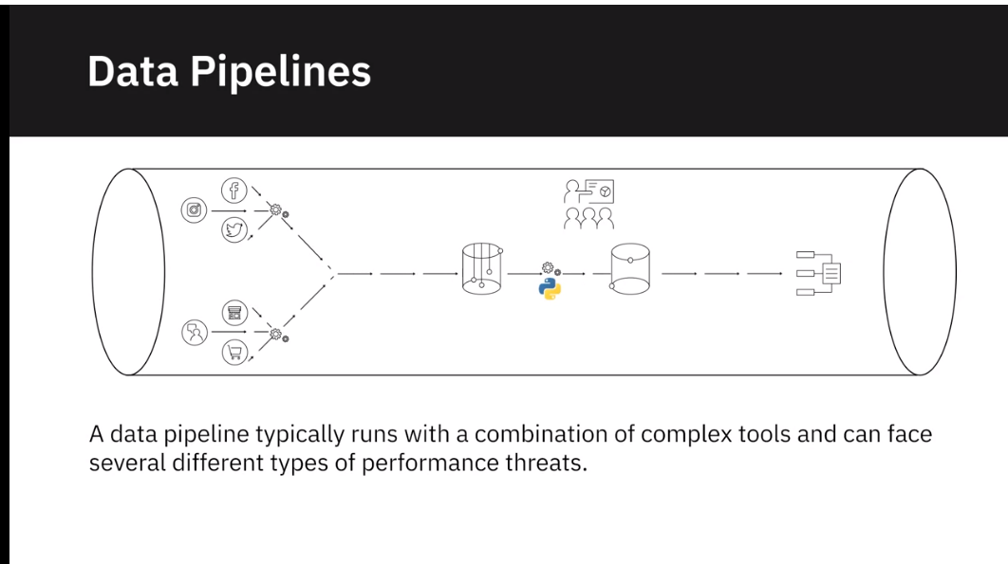

Data Pipelines Performance Threats

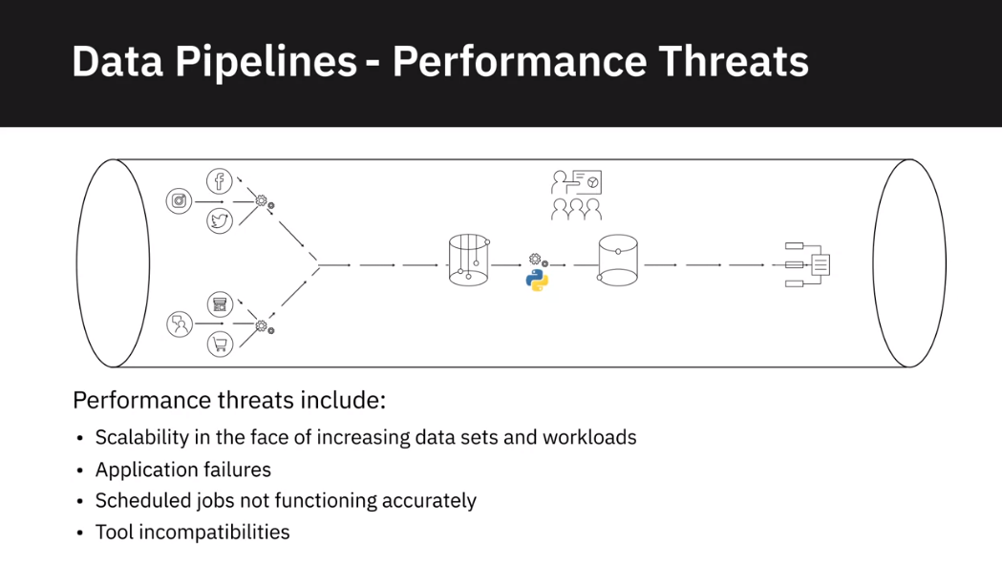

Data Pipeline Performance Metrics

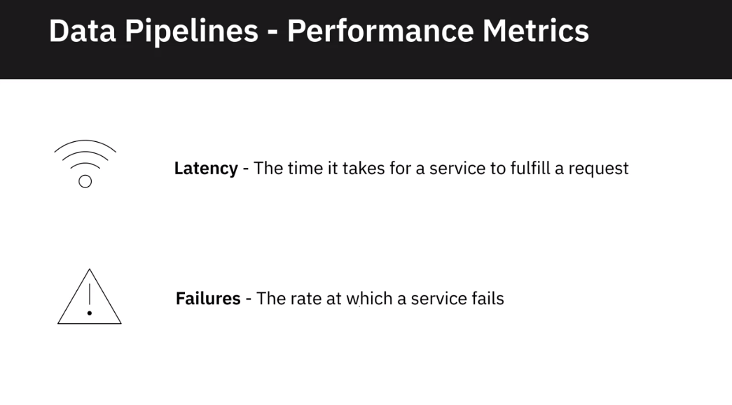

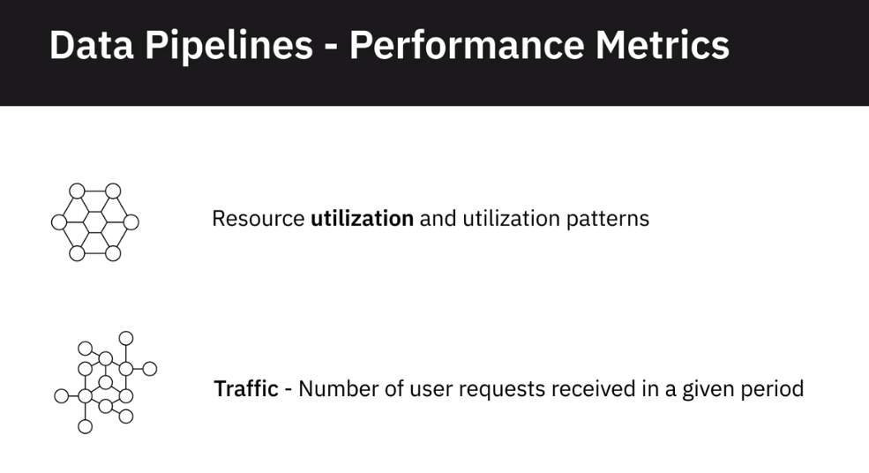

Troubleshooting

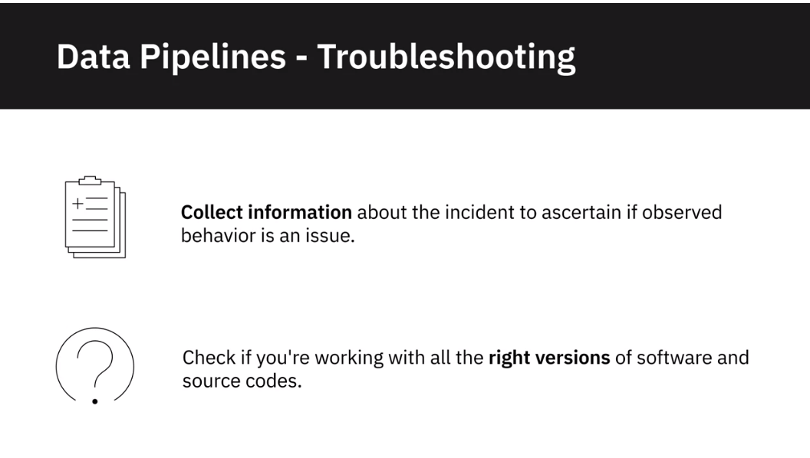

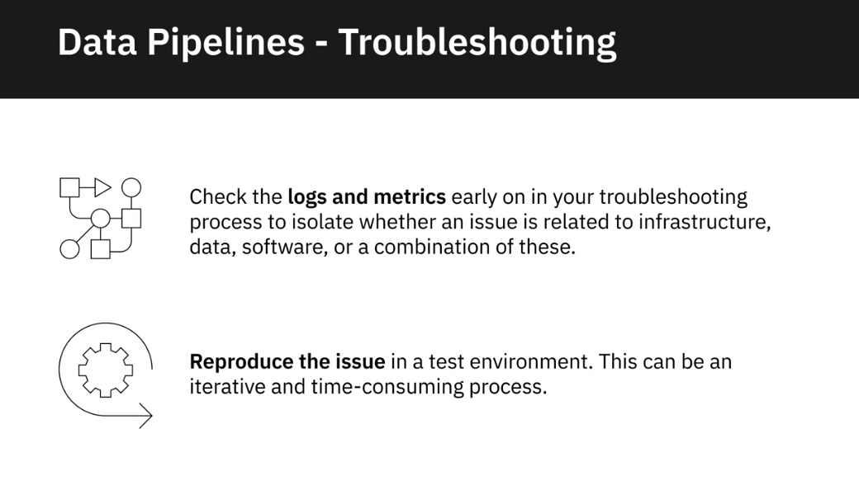

Database Opterimisation and Performance

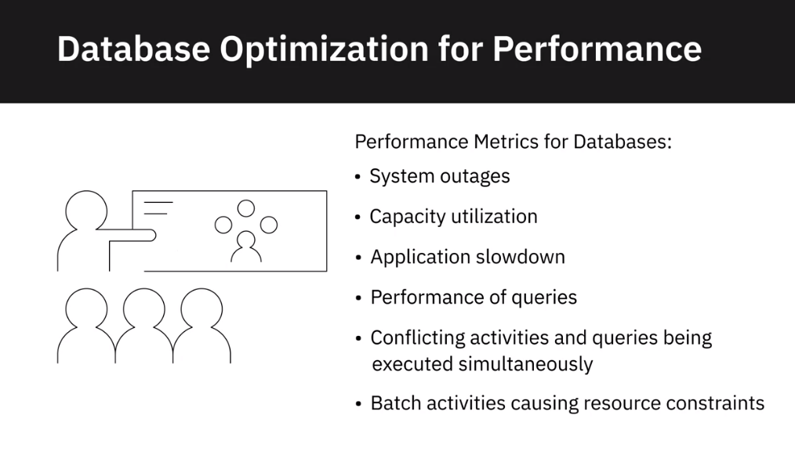

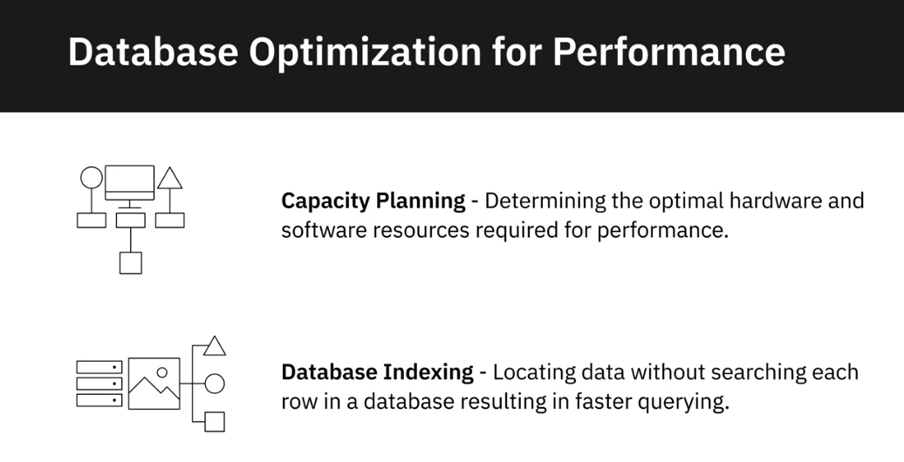

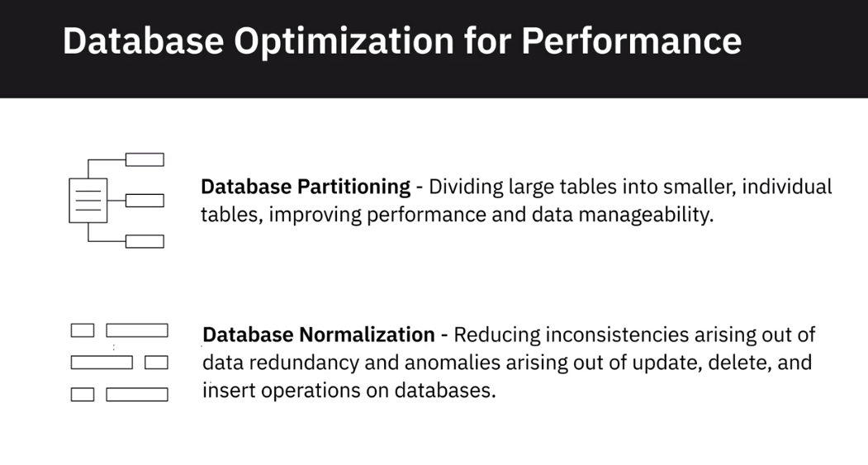

Monitoring Systems

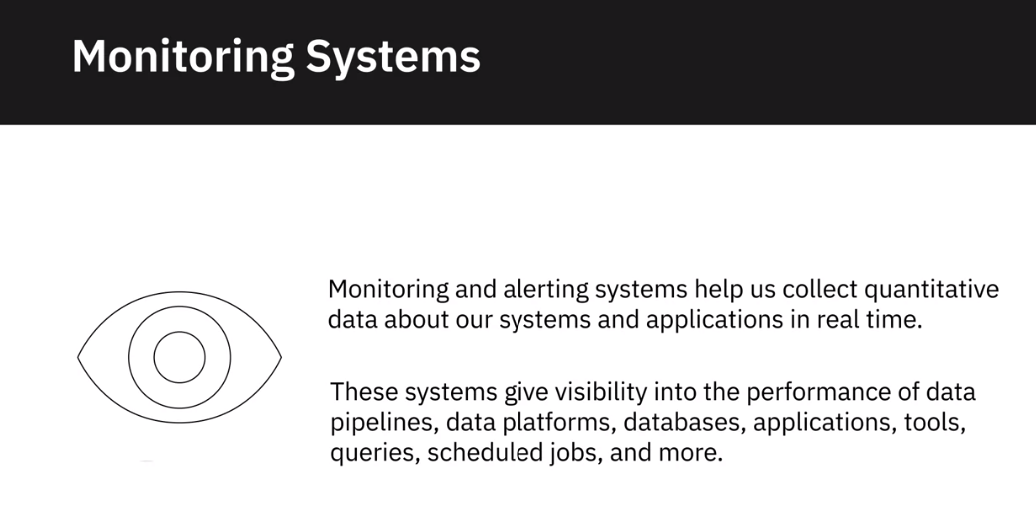

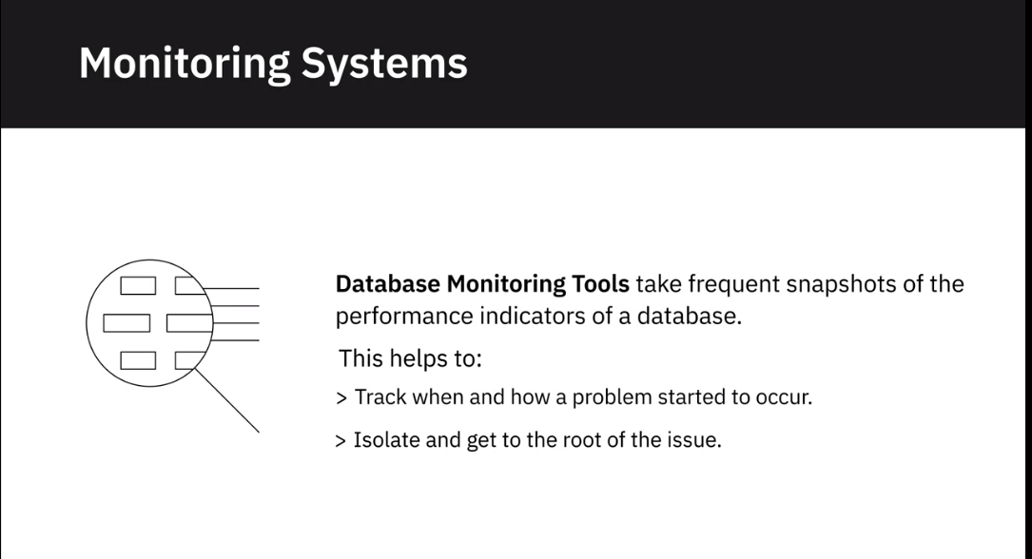

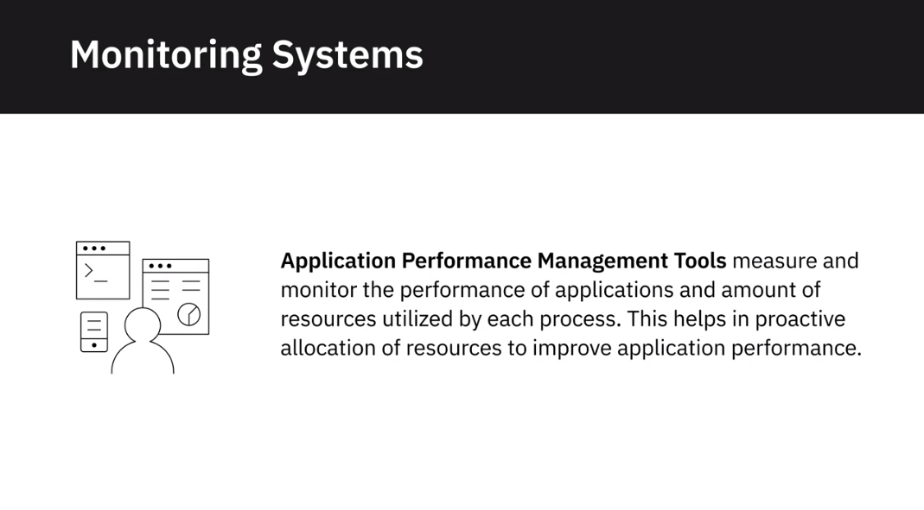

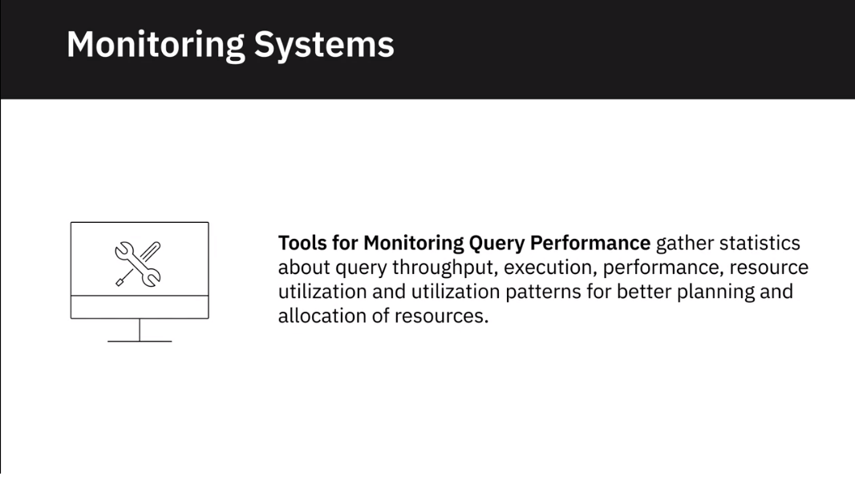

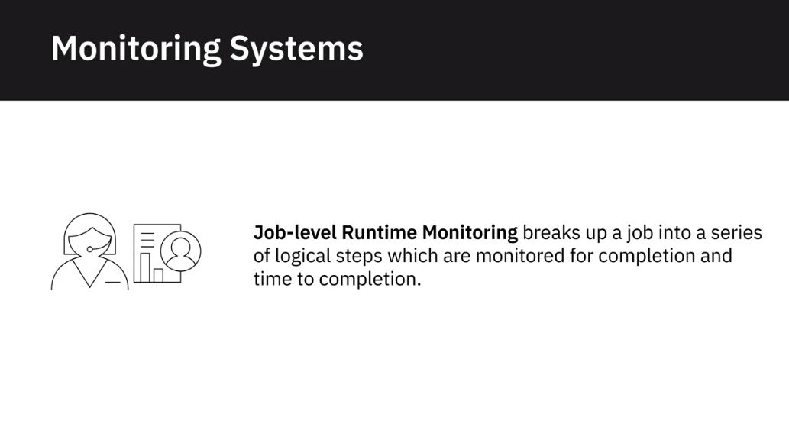

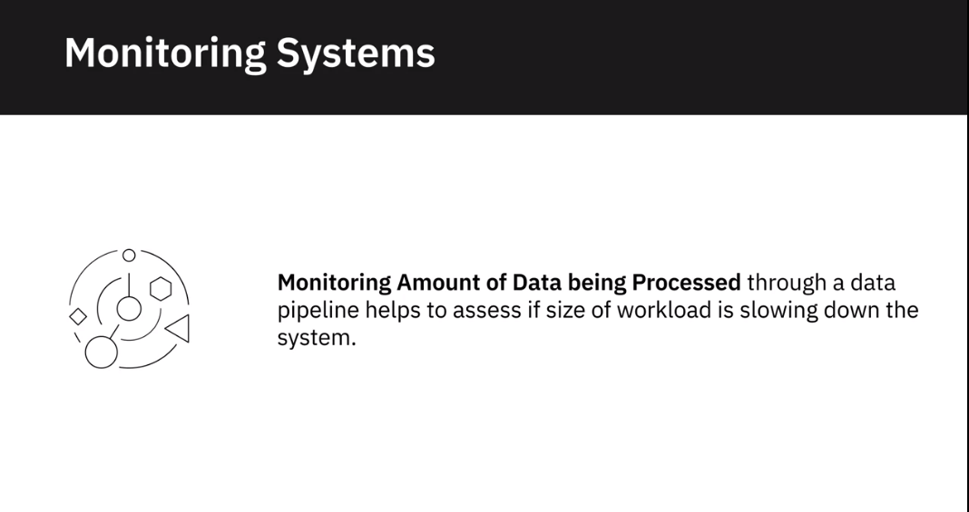

Maintenance Schedules

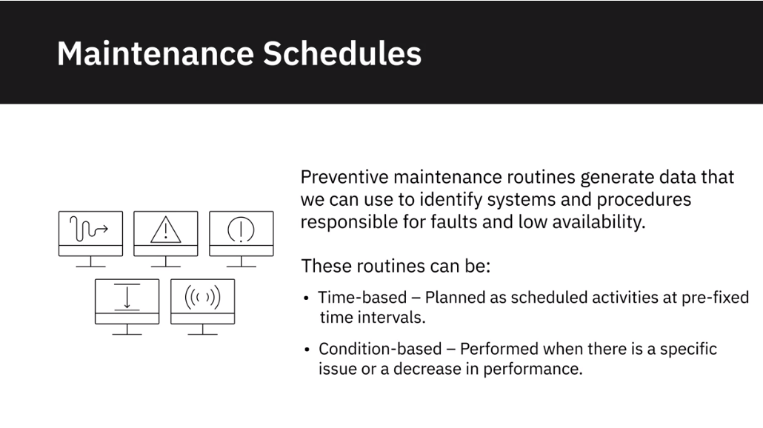

**Lab: Explore your dataset using SQL queries using Datasette**

**Dataset:**

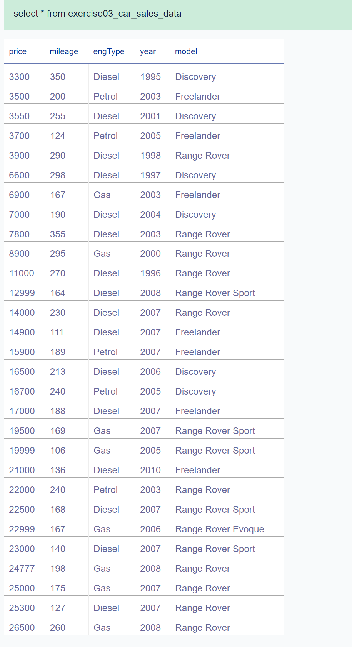

Commands Ran

Execute the following query to check the maximum price.

*select max(price) as max_price from exercise03_car_sales_data*

Execute the following query to display the distinct models.

*select distinct(model) from exercise03_car_sales_data;*

**Governance and Compliance**

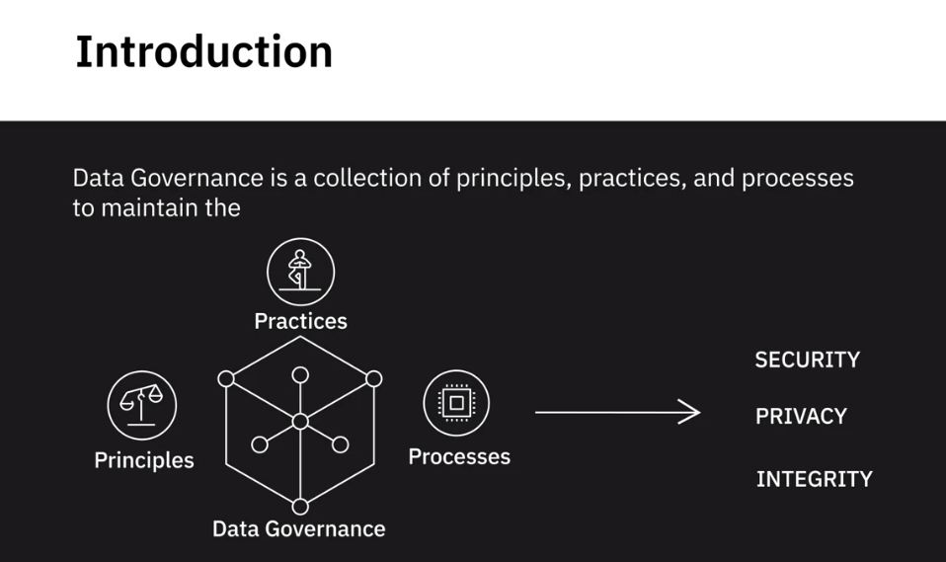

**Data that needs governance**

**Personal Data**

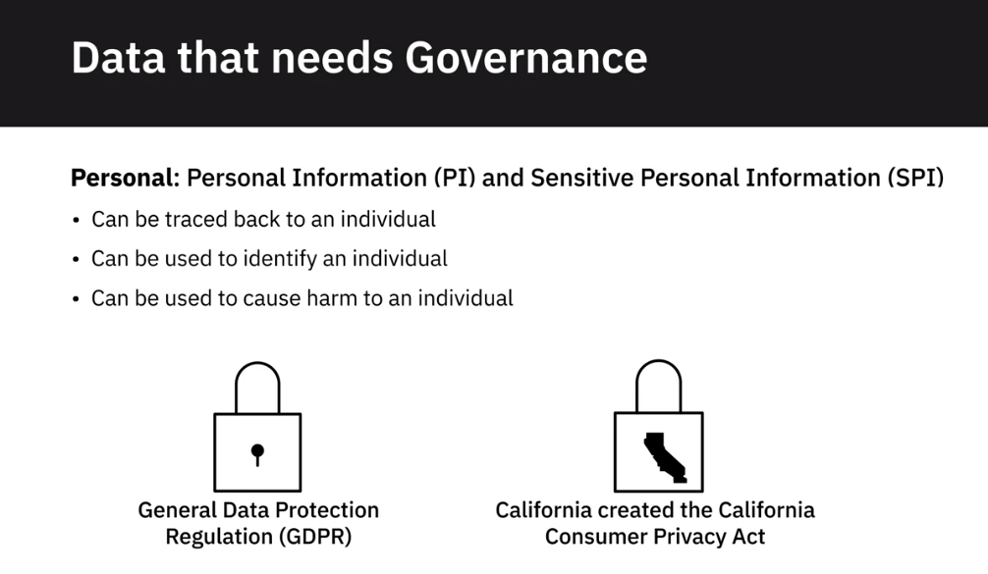

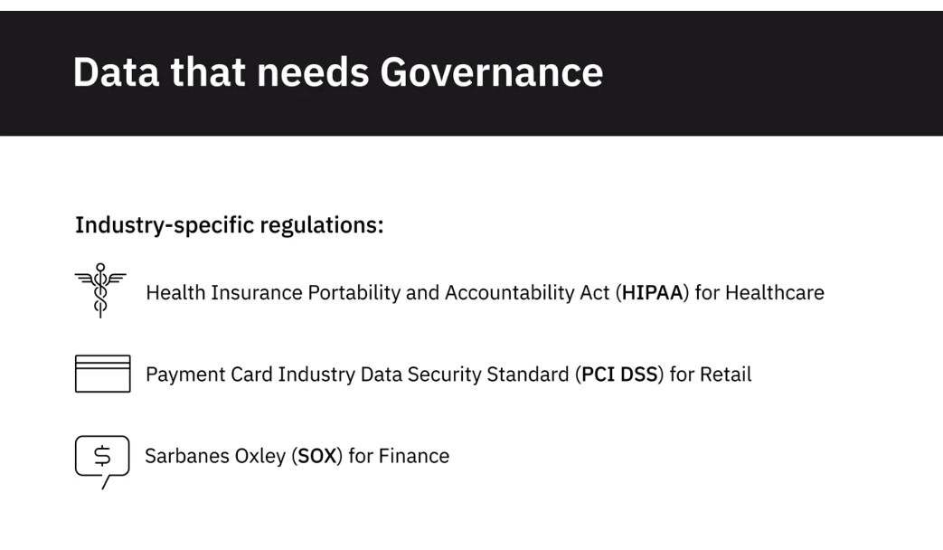

Compliance

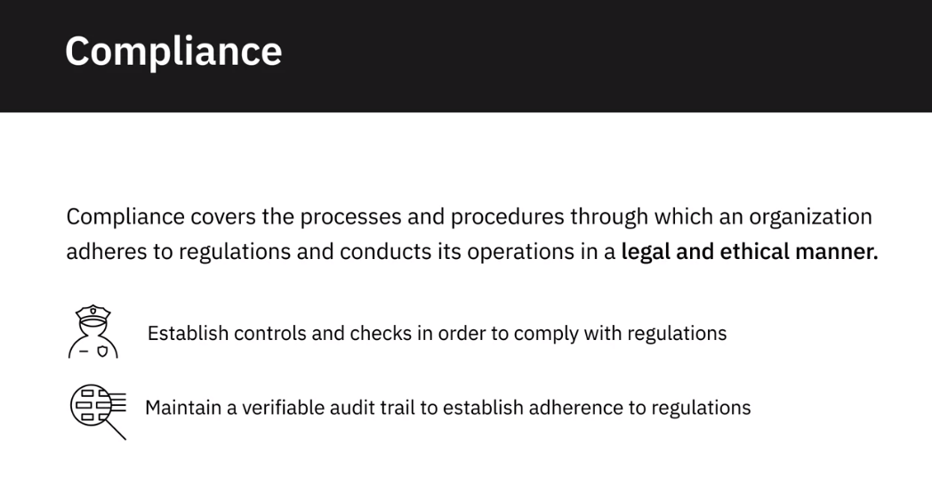

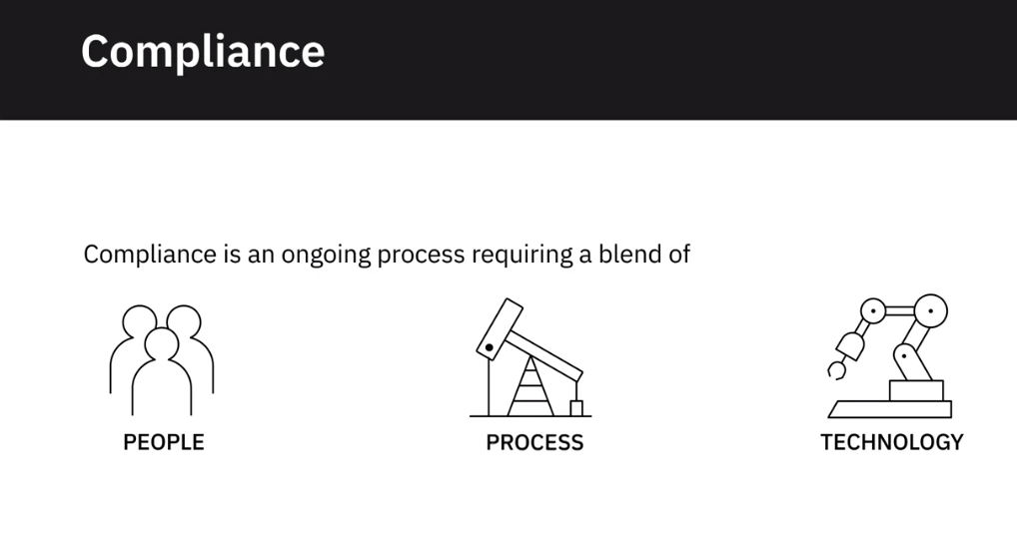

Data Lifecycle: Acquisition

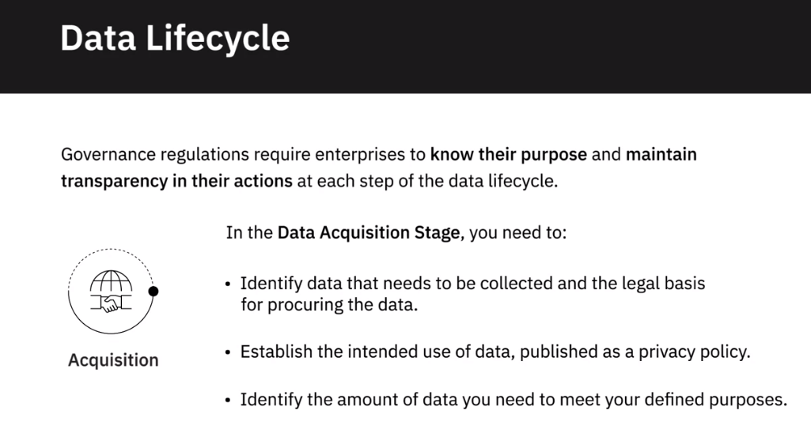

Data Lifecycle: Processing

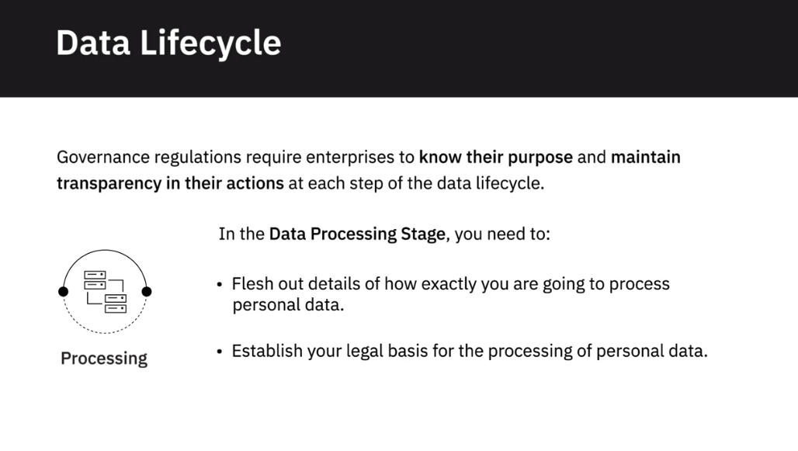

Data Lifecycle: Storage

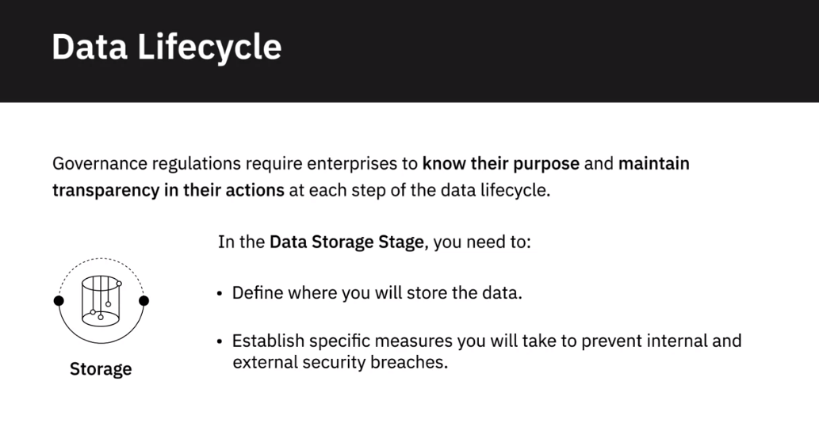

Sharing

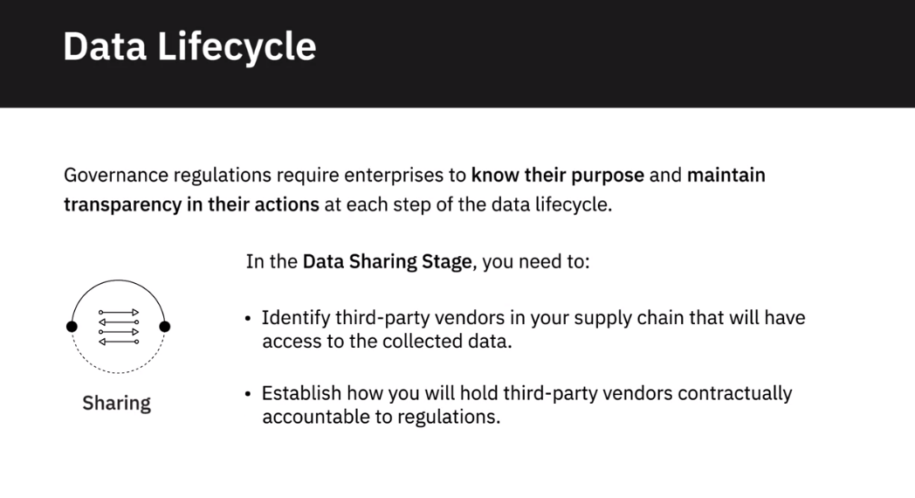

Retention and Disposal

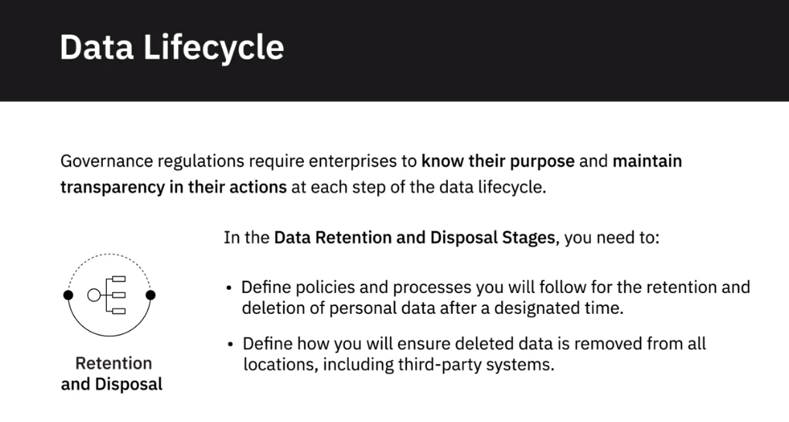

Technology as an enabler

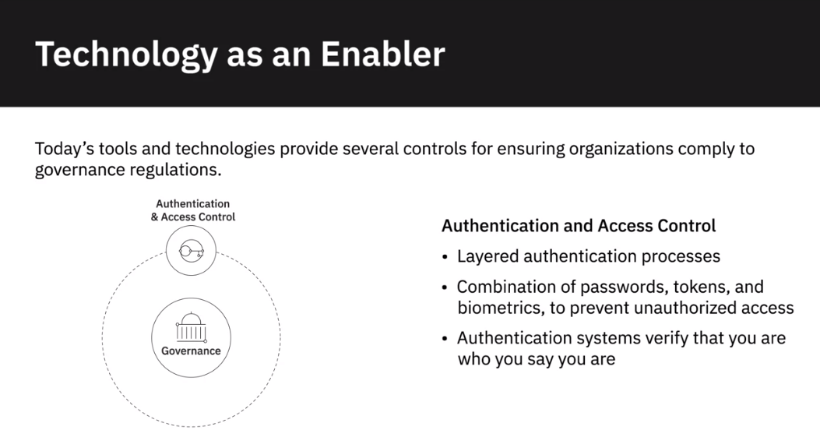

Data encryption

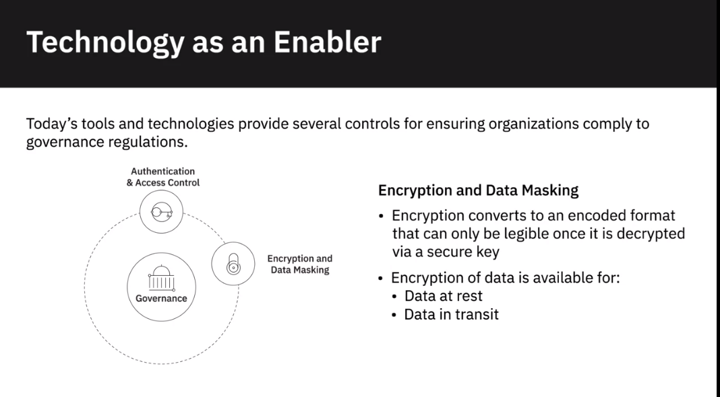

Data Masking

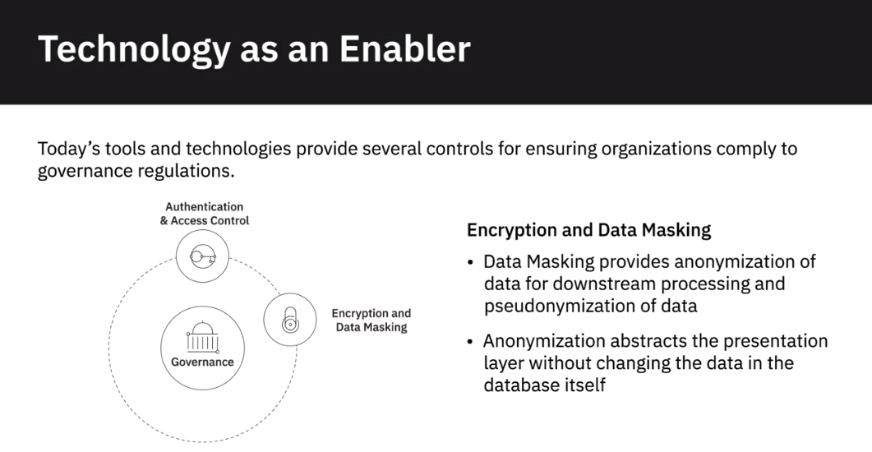

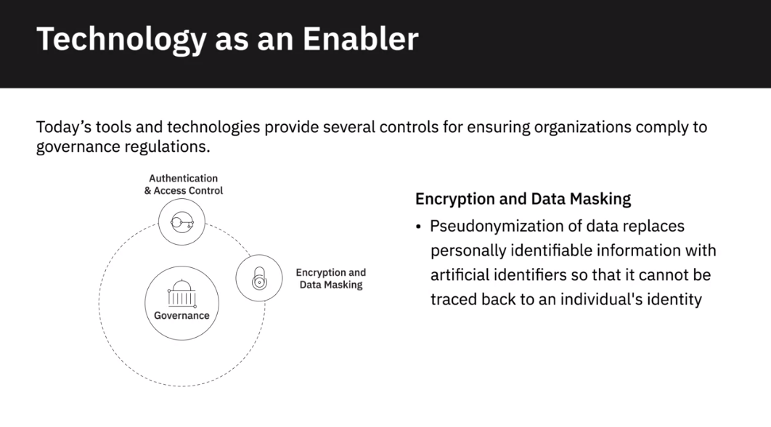

Hosting

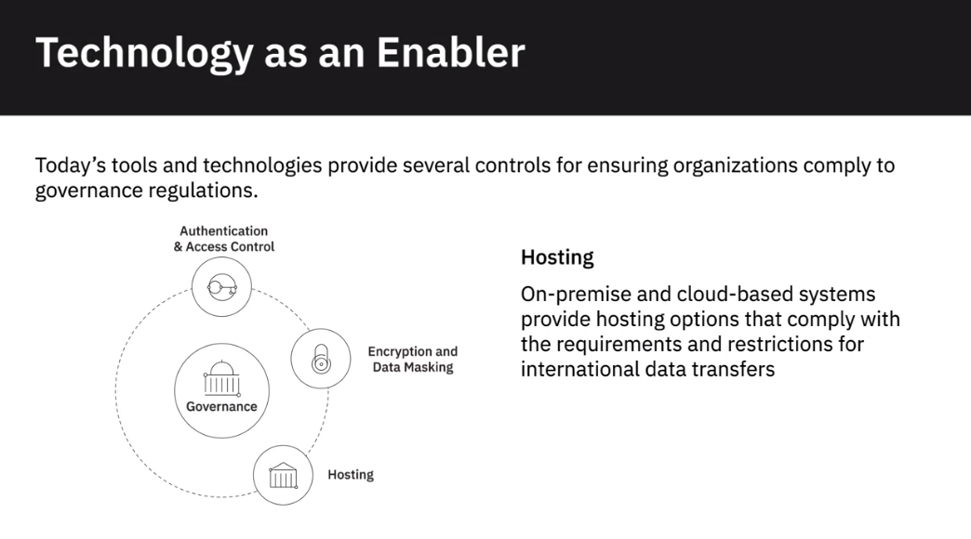

Monitoring and alerting

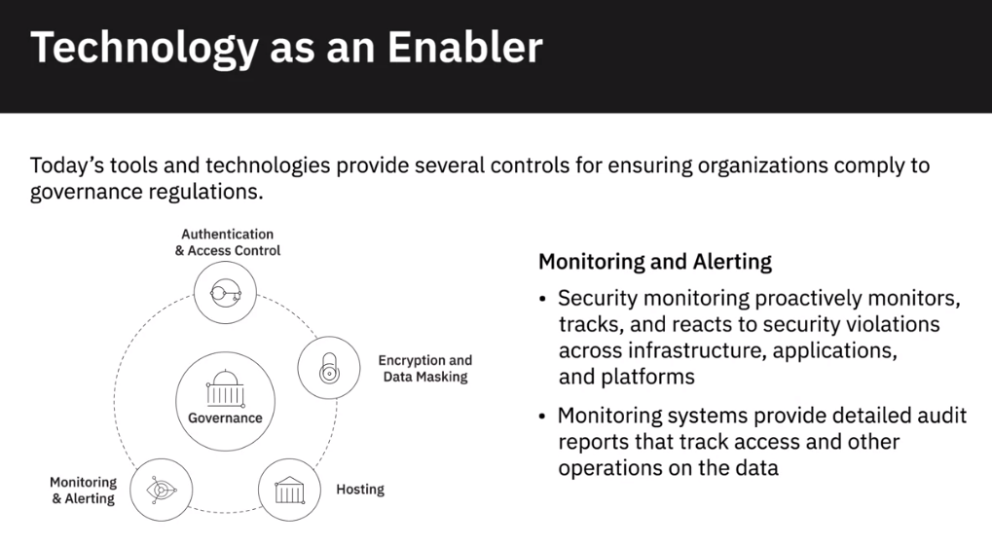

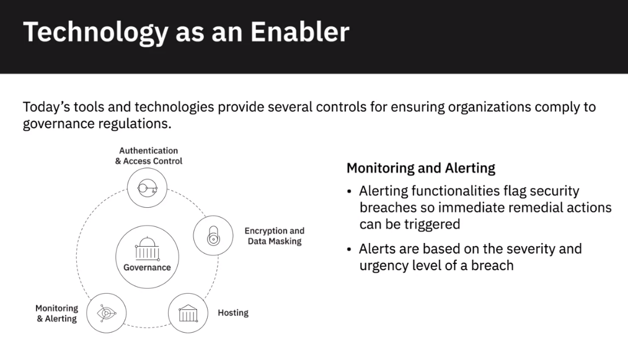

Data Erasure

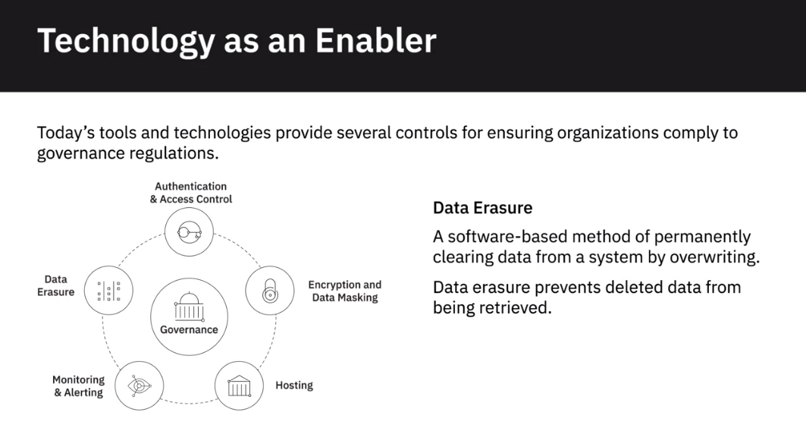

# Optional: Overview of the DataOps Methodology

Gartner defines DataOps as a collaborative data management practice focused on improving the communication, integration, and automation of data flows between data managers and consumers across an organization. DataOps aims to create predictable delivery and change management of data, data models, and related artifacts. DataOps uses technology to automate data delivery with the appropriate levels of security, quality, and metadata to improve the use and value of data in a dynamic environment.” (Source: <https://blogs.gartner.com/nick-heudecker/hyping-dataops/>) A small team working on a simpler or limited number of use cases can meet business requirements efficiently. As data pipelines and data infrastructures get more complex, and data teams and consumers grow in size, you need development processes and efficient collaboration between teams to govern the data and analytics lifecycle. From data ingestion and data processing to analytics and reporting, you need to reduce data defects, ensure shorter cycle times, and ensure 360-degree access to quality data for all stakeholders. DataOps helps you achieve this through metadata management, workflow and test automation, code repositories, collaboration tools, and orchestration to help manage complex tasks and workflows. Using the DataOps methodology ensures all activities occur in the right order the right security permissions. It helps set in a continual process that allows you to cut wastages, streamline steps, automate processes, increase throughput, and improve continually. Several DataOps Platforms are available in the market, some of the popular ones being IBM DataOps, Nexla, Switchboard, Streamsets, and Infoworks.

## DataOps Methodology:

The purpose of the DataOps Methodology is to enable an organization to utilize a repeatable process to build and deploy analytics and data pipelines. Successful implementation of this methodology allows an organization to know, trust, and use data to drive value.

It ensures that the data used in problem-solving and decision making is relevant, reliable, and traceable and improves the probability of achieving desired business outcomes. And it does so by tackling the challenges associated with inefficiencies in accessing, preparing, integrating, and making data available.

In a nutshell, the DataOps Methodology consists of three main phases:

* The **Establish DataOps Phase** provides guidance on how to set up the organization for success in managing data.
* The **Iterate DataOps Phase** delivers the data for one defined sprint.
* The **Improve DataOps Phase** ensures learnings from each sprint is channeled back to continually improve the DataOps process.

The figure below presents a high-level overview of these phases and the key activities within each of these phases.

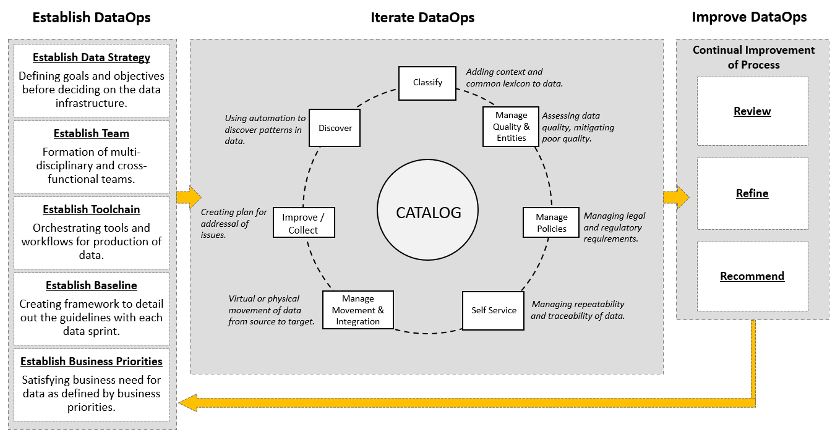

## Benefits of using the DataOps methodology:

Adopting the DataOps methodology helps organizations to organize their data and make it more trusted and secure. Using the DataOps methodology, organizations can:

* Automate metadata management and catalog data assets, making them easy to access.
* Trace data lineage to establish its credibility and for compliance and audit purposes.
* Automate workflows and jobs in the data lifecycle to ensure data integrity, relevancy, and security.
* Streamline the workflow and processes to ensure data access and delivery needs can be met at optimal speed.
* Ensure a business-ready data pipeline that is always available for all data consumers and business stakeholders.
* Build a data-driven culture in the organization through automation, data quality, and governance.

As a data practitioner, using the methodology can help you reduce development time, cut wastages and duplication of effort, increase your productivity and throughput, and ensure that your actions produce the best possible quality of data.

With DataOps, data professionals, consumers, and stakeholders can collaborate more effectively towards the shared goal of creating valuable insights for business. While implementing the methodology will require systemic change, time, and resources, but in the end, it makes data and analytics more efficient and reliable.

Interestingly, it also opens up additional career opportunities for you as a data engineer. **DataOps Engineers** are technical professionals that focus on the development and deployment lifecycle rather than the product itself. And as you grow in experience, you can move into more specialist roles within DataOps, contributing to defining the data strategy, developing and deploying business processes, establishing performance metrics, and measuring performance.